GEN Z-FOCUSED BUDGETING: REVOLUTIONIZING PERSONAL FINANCE WITH TAILORED SOLUTIONS

FARREL GUNAWAN
SHAWN STEPHEN ABOK

BACHELOR OF FINANCIAL TECHNOLOGY (HONOURS)
FACULTY OF BUSINESS AND INFORMATION SCIENCE
UCSI UNIVERSITY
APRIL 2025
A project completed as part of the requirements for the
BACHELOR OF FINANCIAL TECHNOLOGY (HONOURS)

GEN Z-FOCUSED BUDGETING: REVOLUTIONIZING PERSONAL FINANCE WITH TAILORED SOLUTIONS

by
FARREL GUNAWAN
SHAWN STEPHEN ABOK

APRIL 2025
ABSTRACT
The Capstone Project works on enhancing a dedicated budgeting application for Gen Z audience members by understanding their unique financial behaviors and spending habits. The application system includes essential characteristics that consist of adaptable subscription record-keeping, along with aim-setting capabilities and transaction saving, along dynamic dashboard features. The app stimulates prolonged user interaction with badges and streak features so users can receive instant financial data to maintain expense control. The design includes educational resources with financial tips, along with motivational quotes, specifically to improve financial literacy among Gen Z users. Through behavioral analysis, the application enables users to gain better financial habits while controlling their impulsive spending behavior. User tests confirm this customized method successfully solves the key deficits of present budgeting applications since these tools normally fail to adapt to individual needs and maintain user interest. The results indicate that the app produces positive effects on both budgeting techniques and lasting financial learning. The implementation of personalized features linked to tech-savvy younger users within this project shows how financial tools should be adapted to build long-term, sustainable financial behaviors while improving overall financial well-being.

Keywords: Personalized Budgeting, Gen Z, Financial Behavior, Gamification, Financial Literacy, Behavioral Analysis

ACKNOWLEGEMENT
I would like to begin by expressing my deepest gratitude to God Almighty for granting me the strength, wisdom, and perseverance to complete this project. Without His guidance and blessings, this achievement would not have been possible. My heartfelt appreciation goes to my supervisors, Dr. Nurul 'Iffah Binti M. A. Zaaba and Dr. Leow Hon Wei, for their invaluable support, guidance, and dedication throughout this journey. Their expertise and constructive feedback have played a critical role in shaping this study.
My gratitude extends to all instructors as well as mentors who shared their knowledge, which enabled me to develop this capstone project successfully. Their valuable contributions have significantly improved my comprehension and my competence levels. A heartfelt gratitude goes to my family, along with friends, because they gave complete backing through this whole journey and maintained their patience as well as motivational spirit. The enduring love between us has helped me stay focused even when I faced my toughest periods.
I give my appreciation to the survey respondents, along with the participants who conducted the user acceptance testing, because their input enabled the project to reach its best state. This study expresses heartfelt gratitude to the researchers as well as the developers and practitioners who inspired its foundation through their contributions. Financial technology research by these professionals forms the essential base of knowledge for my professional efforts.

TABLE OF CONTENTS
ABSTRACT i

TABLE OF CONTENTS ii

CHAPTER 1 (TASK 1)
1. INTRODUCTION 1
2. BACKGROUND 2
3. RELATED WORK 5
3.1 Comparison Table (Confidentiality Issues Focus) 7
3.2 Comparison Table (Data Theft Due to Identity Fraud Focus) 7
4. DISCUSSION AND ANALYSIS 8
4.1 Results or Evaluation of the Proposed Solution (Confidentiality Issues) 9
4.2 Results or Evaluation of the Proposed Solution (Data Theft Due to Identity Fraud) 10
5. CONCLUSION AND FUTURE RESEARCH 11
5.1 Conclusion 11
5.2 Future Research 11
CHAPTER 2 (TASK 2)
6. QUESTION 1 12
6.1 Comparison of Services Provided by Alibaba Cloud and AWS 12
7. QUESTION 2 14
7.1 Comprehensive Knowledge and Skill Acquisition 14
7.2 Career Advancement and Marketability 14
8. REFERENCES 16
9. APPENDICES 18

LIST OF TABLES
Table 2.1 Research Paper Comparison………………………………………………………25

Table 2.2 Reviewed System Comparison……………………………………………………52

Table 3.1 Functional Requirements………………………………………………………….72

LIST OF FIGURES
Figure 1.1: Personal Finance Elements……………………………………………………2
Figure 1.2: Prevalence of functionalities in personal finance management applications....5
Figure 1.3: Influence of Emotional and Cognitive Biases on Financial Decisions……….5
Figure 1.4: Integration Issues with Finance Apps………………………………………...7
Figure 1.5: Key Issues in Current Financial Management Applications………………….8
Figure 1.6: Benefits of Personalized Financial Insights & Embedded Financial Education…………………………………………………………………………………12
Figure 1.7: Financial Data Breaches in Different Platforms……………………………..15
Figure 1.8: Challenges Impacting AI-driven Predictive Analytics in Financial Management………………………………………………………………………………16
Figure 1.9: Report Structure………………………………………………………………17
Figure 2.1: Financial Behaviour…………………………………………………………..20
Figure 2.2 Financial Research Framework……………………………………………….20
Figure 2.3: Flow Chart of Case-Based Reasoning………………………………………..31
Figure 2.4: eExpense’s Debit……………………………………………………………..33
Figure 2.5: eExpense’s Credit…………………………………………………………….34
Figure 2.8: Wallet’s Expense Records……………………………………………………39
Figure 2.12: Monefy’s User Interface…………………………………………………….44
Figure 2.14: Belanjawanku’s Spending Guide…………………………………………....49
Figure 2.16: Budget Calculator……………………………………………………………54
Figure 3.1 MVC Architecture Basic Data Flow…………………………………………..65
Figure 3.2 Gantt Chart…………………………………………………………………….71
Figure 4.1: Libraries Imported…………………………………………………………….90
Figure 4.2: Mount Google Drive…………………………………………………………..90
Figure 4.3: Database Setup………………………………………………………………...92
Figure 4.8: UI Components………………………………………………………………..96
Figure 4.9: Authentication Choice, Login, Register Screen………………………………97
Figure 4.13: Dashboard…………………………………………………………………...104
Figure 4.16: Welcome Page……………………………………………………………….110
Figure 4.19: Main Menu Page…………………………………………………………….113
Figure 4.23: Budgets Feature……………………………………………………………..117
Figure 4.33: Badges Feature……………………………………………………………..127
Figure 4.34: Use Case Diagram………………………………………………………….129
Figure 4.35: Login & Signup Activity Diagram…………………………………………131
Figure 4.37: Account Balance, Budget Category, Transaction, and Dashboard Activity Diagram………………………………………………………………………………….133
Figure 4.38: Wishlist Activity Diagram…………………………………………………134
Figure 4.39: Login & Setup Sequence Diagram…………………………………………136
Figure 4.40: Features Sequence Diagram………………………………………………..137

CHAPTER 1: INTRODUCTION
1.1 Overview
The section details the reason for building the proposed personal finance management system, along with its historical development. The paper details the modern problems affecting personal financial actions, focusing on Generation Z users, as it criticizes existing financial programs because they lack personalized features, behavior tracking, and built-in goal-saving functions. The goals and value of the research are clarified in this section, along with evidence supporting that the combination of AI and intelligent analytics technology provides advanced solutions to improve budgeting and expense tracking, and financial education.

1.2 Background of Study
The way a person controls their finances determines their economic stability, together with their quality of life and lasting financial security level. The essential components of effective management include budgeting as well as saving money through investing, which pairs with expense tracking for debt management and retirement planning (Hilgert, Hogarth, & Beverly, 2003). Each essential financial task helps people use their resources well and protect themselves from risks while following their financial goals. Many empirical investigations demonstrate the existence of extensive global illiteracy in financial matters among the population. The research by Lusardi and Mitchell (2014) revealed that approximately two-thirds of adults fail to possess sufficient financial understanding needed for sound decision-making because of which results in financial difficulties along with unmanageable debt, and inadequate retirement funds.
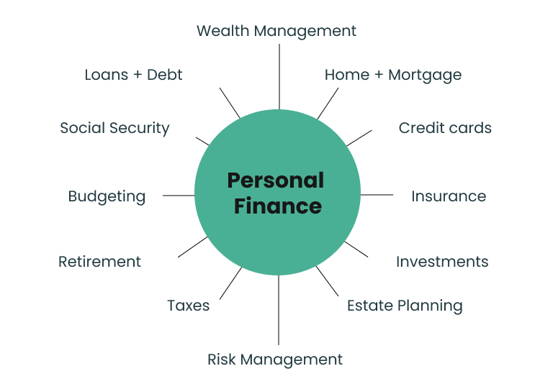
Figure 1.1: Personal Finance Elements
Source: (Annuity.org, 2025)

Current financial conditions make personal finance management considerably more difficult to handle. Various financial products, along with simple credit availability and digitalized payments, along with economic irregularity, create effective finance management challenges for individuals (Xiao & Porto, 2017). Modern students who rely on digital media resist traditional classroom teaching methods, including seminars, which traditional programs like classroom instruction (Mandell & Klein, 2009). Specific behavioral patterns combined with habits enable AI and ML technologies to deliver personal instant financial support (Gomber et al., 2018).
The research conducted by JPMorgan Chase & Co. indicates that more than 60% of young adults have trouble saving money because of their spontaneous purchasing habits, which digital transactions enable (JPMorgan Chase, 2020). Sarah works as a professional but spends too much money on spontaneous buys using digital payment systems. Budgeting applications give conventional, generic money-saving tips that fail to match her habits. An AI-powered financial management system would study her purchase records to detect sudden purchasing impulses and develop special suggestions that would result in superior financial security.
The digital finance market is currently expanding due to Generation Z (Gen-Z), who were born from 1997 to 2012, because they show exceptional mastery of technology alongside their commitment to digital-first financial experiences. Research from Morgan Stanley (2022) finds that Generation Z demonstrates specific approaches to financial controls through demanding simple access and instant results combined with high custom settings. High-end digital features and instant feedback through mobile apps and wallets drive this demographic to handle financial business. The Deloitte (2021) research shows that Gen-Z people favor personal finance applications that deliver proactive guidance alongside custom-made suggestions. Although these consumers demonstrate superior technical skills, most of them lack sufficient financial knowledge, which exposes them to hazardous financial choices such as uncontrollable spending and debt issues, and inadequate savings accumulation. The ability to create AI-driven financial coaching systems that focus on Gen-Z users demonstrates great promise for improving their financial literacy while developing sustainable economic behaviors, because Gen-Z members belong to the digital age.
The studies performed by JPMorgan Chase & Co. demonstrate how 60% of young adults fall short on saving money because they spend excessively through digital payment platforms (JPMorgan Chase, 2020). Young professional Sarah holds a decent income but badly spends her money on hasty digital wallet purchases. Budgeting applications from the past provide universal saving guidelines that do not match Sarah's conduct. Through analyzing her transaction data, the AI system would detect her pattern of buying impulsively, so it could give specific smart recommendations that would result in improved financial stability.
1.3 Problem Statement
Many personal finance applications exist, yet they offer restricted features that primarily include budget planning and generic expense tracking. The platforms usually provide limited capabilities because they lack individualized insights, together with dynamic adaptability features and predictive analysis systems (Garg & Sharma, 2020). Insufficient personalization in recommendations prevents users from interacting with systems effectively because their financial needs remain unaddressed, which produces poor management results.
Current financial management tools fail to deliver immediate adjustments of financial recommendations when users encounter modifications in their circumstances, along with behavioral change. General financial recommendations lose their value during economic decline since they fail to address the personal financial consequences that users face. The COVID-19 pandemic demonstrated this shortcoming vividly because Pew Research Center's survey (2020) proved that more than half of American people faced financial challenges from both decreased earnings and unexpected healthcare bills. Time-sensitive financial assistance and customizable guidance remained unattainable to users through traditional budgeting systems throughout the uncertain period of economic uncertainty.

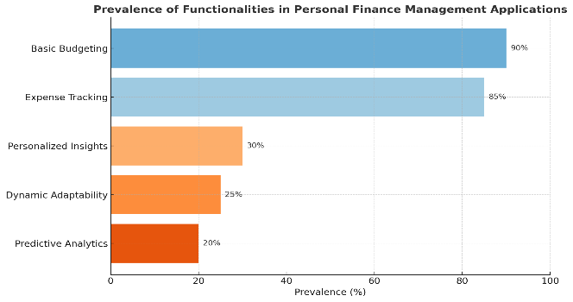 | 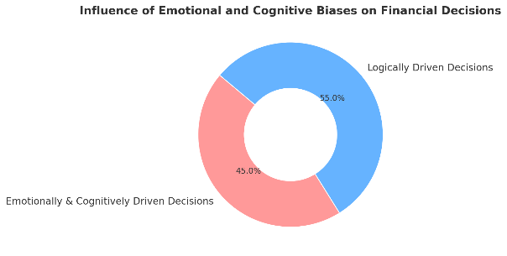
Figure 1.2: Prevalence of functionalities in personal finance management applications  Source: (Garg & Sharma, 2020) | Figure 1.3: Influence of Emotional and Cognitive Biases on Financial Decisions  Source: (Behavioral Economics Lab, 2019)

Current financial management applications do not have enough analysis capabilities related to behavioral insights. Users need behavioral intelligence to monitor psychological factors that influence their purchasing choices. The Behavioral Economics Lab at Harvard University (2019) established that emotional and cognitive biases create interference in more than 45% of financial handling decisions, thus, these choices resist logical assessment. Standard finance management software applications fail to deliver complete behavioral elements content within their operations. The absence of behavioral analysis features in the system results in users' lack of understanding regarding why they make hasty purchases and why they employ poor saving practices.
The integration function remains a problem with existing finance applications since they need users to manually enter data while lacking complete platform synchronization with bank accounts and credit provider systems, and digital wallets. User surveys conducted by Experian in 2021 showed that manual data entry and entry errors they experienced as the main factors behind abandoning their financial management app usage. The current financial management approach used by entrepreneur Emma presents typical problems since manual integration leads to inconsistent data and both tracking errors and poor decision-making. According to Ernst & Young (2019), research exists for a documented lack of financial management tools that suit entrepreneurs and freelancers due to fragmented technologies.
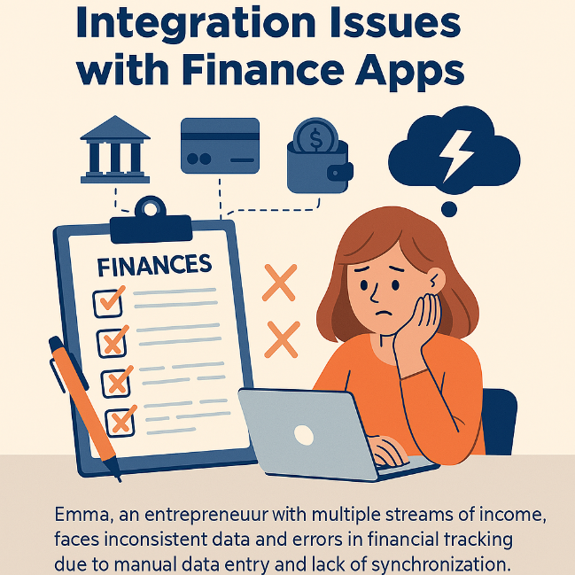
Figure 1.4: Integration Issues with Finance Apps
Source: (Ernst & Young (EY), 2019) & (Experian, 2021)

Despite progress, the main challenge remains insufficient education-based help features in these platforms. Current financial applications neglect essential education modules, which results in users lacking the necessary skills for effective use of the provided financial advice. Financial Industry Regulatory Authority (FINRA) studies demonstrated that people without enough financial knowledge tend to handle credit poorly, then spend excessively and accumulate debt without grasping the consequences. Platforms operating today make blanket assumptions about user financial knowledge, even though their users have varying educational levels in finances.
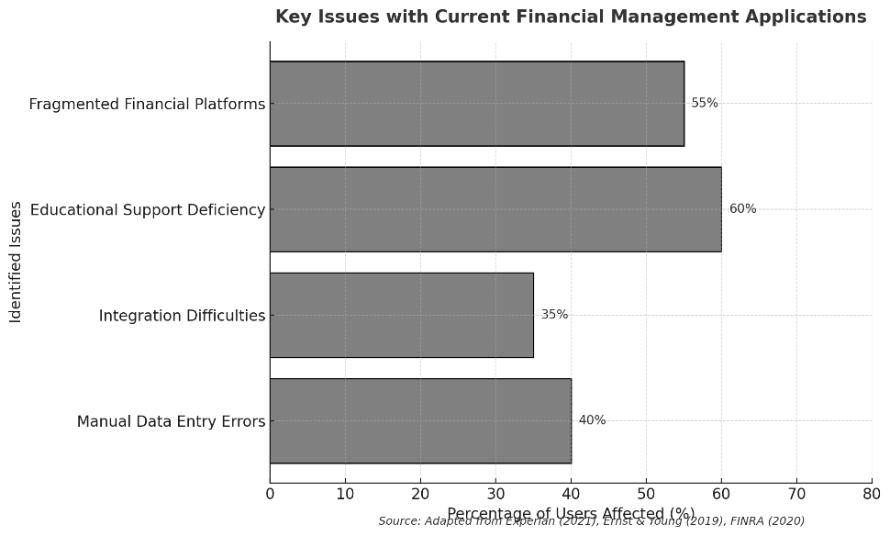
Figure 1.5: Key Issues in Current Financial Management Applications
Source: (Experian, 2021) & (Ernst & Young, 2019) & (FINRA, 2020)

The current personal finance tools show reduced effectiveness because of their major drawbacks that demand enhanced solutions, which can be both adaptive and behaviorally insightful, and educationally integrated financial coaching systems.
Existing finance apps do not deliver specific personalized digital experiences that Generation Z smartphone users need due to their distinct requirements. An approach to financial advice that relies on generic advice leads Gen-Z users to stop using finance apps because standard advice does not consider their financial behavior or spending habits, as explained by PwC (2022). Financial management applications currently available on the market lack sufficient ability to analyze user behavior patterns. The study of behavior patterns constitutes an essential component because it demonstrates to users which emotional factors impact their purchasing choices. People make financial choices under the influence of cognitive biases along with emotional distortions to such an extent that it surpasses 45% the extent of rational decision-making, according to the Behavioral Economics Lab at Harvard University (2019). Users in the Gen-Z generation develop wasteful financial behaviors as their technological tools lack adequate behavioral forecast features.

1.4 Research Objectives
The primary objectives of this research are to:
- To review budgeting apps as well as personal finance tools through the eyes of Gen Z users.
- To create and include budget system features that address Gen Z preferences with subscription management and impulse buying notification capabilities.
- To examine how financial literacy functions inside the user system might affect users' budgeting practices.
- To ensure that the developed system promotes sustainable budgeting habits while maintaining high usability and engagement levels.
- To integrate a rewards or incentive mechanism (e.g., badges, streaks, or discounts) that encourages consistent budgeting and saving behavior among users.
- To develop a goal-setting feature within the budgeting system that helps Gen Z users save for short-term and long-term goals (e.g., travel, gadgets, education).

1.5 Research Questions
The study aims to explore the following critical research questions:
- What are the positive and negative points of budgeting applications and personal finance tools according to current Gen Z users?
- What key features do Gen Z users need in budgeting systems to effectively manage subscriptions and control impulse purchases?
- What design parameters should a budgeting system use to enhance Gen Z users' financial expertise along with their budgeting practices?
- Which design features and functions can make a budgeting app targeted at Gen Z users both usable long term and engaging to the audience specifically?
- Which components in a customized goal-setting feature influence Gen Z users to develop better financial planning, together with saving practices?

1.6 Significance of Study
Through research efforts, the sector adds major value to users along with fintech by offering customized AI-driven financial decision-making services. The proposed system differs from static advice systems through continuous modification of its operations based on user behavior in real-time to deliver proactive financial guidance (Deloitte, 2020).
Real-life circumstances show that individualized financial evaluation offers extensive advantages to users. Clients who utilized AI-driven financial coaching solutions at Bank of America during 2020 experienced average monthly savings amounting to 15% more than regular budgeting methods, according to the bank report. The AI technology assisted David, a working professional, through personalized alerts and behavioral patterns from his online spending. Through anticipatory reminders along with adjustable online spending limits and suggested activities, his financial responsibility and his total savings improved remarkably.

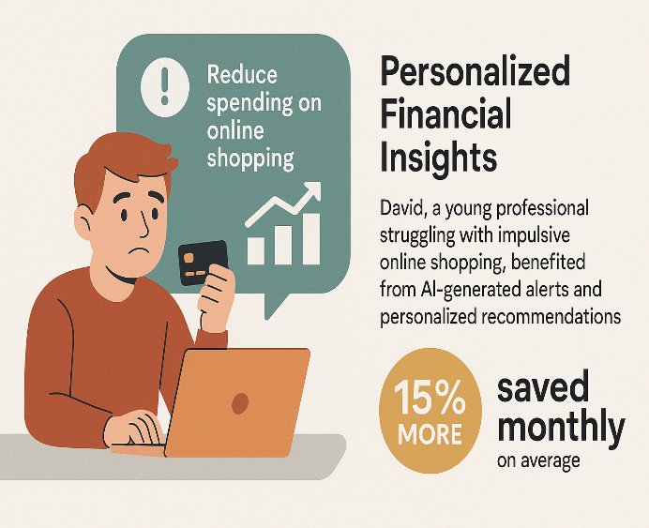 | 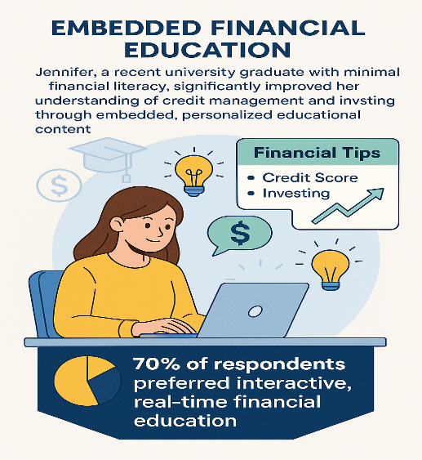
Figure 1.6: Benefits of Personalized Financial Insights & Embedded Financial Education
Source: (Financial Health Pulse: 2021 U.S. Trends Report - Financial Health Network, 2023)

This initiative fills the gaps in financial education through the direct implementation of interactive financial knowledge within the management systems. According to a Financial Health Network (2021) survey, 70% of respondents chose interactive financial knowledge that could be integrated with their daily financial tools instead of separate traditional educational resources. Jennifer improved her financial knowledge about credit management and investment through embedded educational content that adapted to her financial activities within a personal interface inside her financial management system. The real-time education she received enabled her to make confident financial decisions because of better decision-making abilities, leading to enhanced financial stability and growth.
The research results deliver important benefits to both individual users, especially the Gen-Z generation, and the fintech industry through dynamic AI-dependent financial guidance. The proposed system adjusts automatically to current user actions to deliver immediate financial guidance that leads to concrete action (Deloitte, 2020). The system provides Gen-Z users, who seek personal feedback instantaneously, with effective financial planning abilities along with improved financial discipline.

1.7 Scope and Limitations
A prototype will be developed as a comprehensive system that integrates AI technology through financial coaching that offers individualized recommendations and behavior assessment and real-time budget controls, and expense documentation, as well as goal-setting capabilities and extensive financial information areas. The prototype requires the integration of major banking and e-wallet platforms to provide real-time data synchronization according to Chen, Li, Wu, & Luo (2017).
The solution plans to develop a specialized AI-based financial counseling system that serves Gen-Z customers with personal financial guidance, along with behavioral assessment reports and present-time budget tools and extensive expense tracking capabilities, and goal-management features. The system can easily connect to main banking and e-wallet platforms that Gen-Z users mostly use because it ensures immediate data exchange. The implementation of this solution faces challenges due to strict data privacy laws, together with the demand for precise emotional prediction methods and technical difficulties that derive from institution-level financial data collection.
A few major constraints need to be taken into consideration. Data privacy challenges are severe due to the requirement of proper adherence to privacy standards that include the GDPR and CCPA. Capital One experienced a severe data breach impacting more than 100 million customers in 2019 because of the necessity for stringent privacy protection and robust safety measures for financial data (BBC News, 2019).
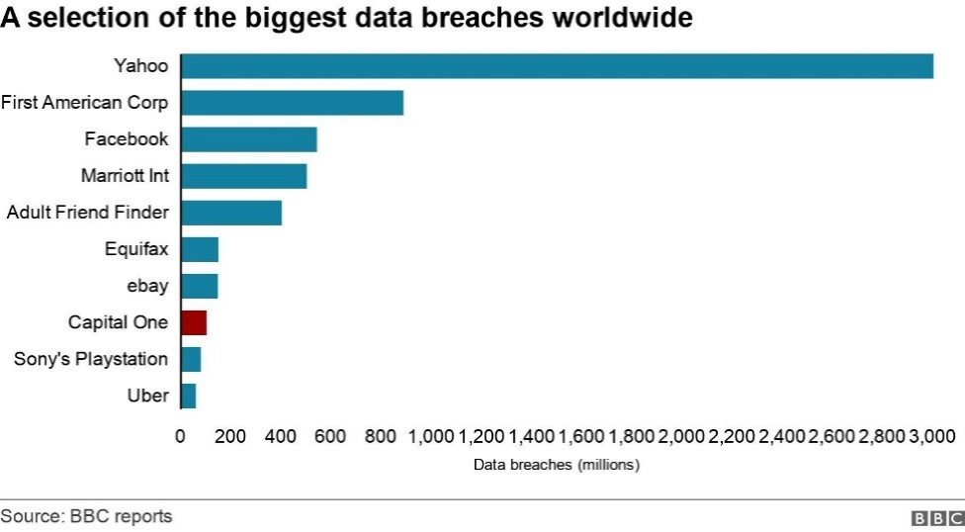
Figure 1.7: Financial Data Breaches in Different Platforms
Source: (BBC News, 2019)

AI-driven insights depend on the precise and whole user-provided data for their effectiveness to function. However, unpredictable emotional and psychological elements that characterize human financial behavior create uncertainty, which ultimately affects the predictions of these models. Toyota demonstrated that human emotions regularly supersede logical financial choices in real-life behavioral economic situations. The Consumer Financial Protection Bureau (CFPB) conducted financial decision-making studies in 2017, which revealed that stress-related behavioral issues and anxiety, and impulsive actions from people lead to unpredictable financial decision-making, making predictive analytics unreliable.
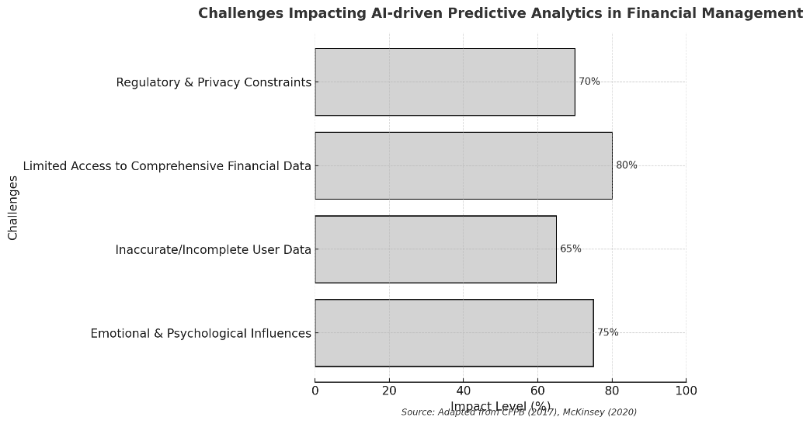
Figure 1.8: Challenges Impacting AI-driven Predictive Analytics in Financial Management
Source: (Reports | Consumer Financial Protection Bureau, 2025)

Predictive analytics faces significant practical obstacles because it becomes challenging to acquire complete financial data records from financial institutions. Extensive financial data acquisition from banks and service providers faces numerous challenges because banks must follow strict rules, as well as data sharing restrictions and privacy regulations. The McKinsey research in 2020 highlighted obstacles that fintech startups face when trying to obtain extensive financial data from conventional banking institutions, due to which they cannot provide accurate, customized financial guidance.

1.8 Structure of the Paper
The paper is structured as follows:
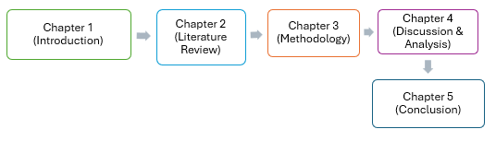
Figure 1.9: Report Structure

- Chapter 1 The text starts by discussing the personal finance effects on society, which are most evident within the Gen Z population.
- Chapter 2: The study reviews currently published literature to evaluate existing financial management applications as part of a gap analysis for innovation.
- Chapter 3 provides details about methodologies in addition to technical information and framework specifications used to create the financial coaching solution.
- Chapter 4 describes a full-scale implementation process providing specific information about programming methods and system infrastructure design, and unified system connectivity approaches.

- Chapter 5 concludes the whole paper from the introduction all the way to the discussion and analysis, and also confirms the success of achieving our research objectives, as well as providing several limitations and recommendations to further improve our proposed system.

CHAPTER 2: LITERATURE REVIEW
2.1 Overview
This chapter examines various proposed solutions along with their respective strengths and disadvantages presented in existing systems and papers. Proposed remedies for these limitations are dissected to determine if available solutions exist.

2.2 Personal Finance
The system of personal finance includes managing cash funds through planning, budgeting, along saving and investing while establishing retirement strategies. Individuals need to base their choices on knowledge to reach both financial security and extended aim accomplishment (Atkinson & Messy, 2012b). Economic stability with enhanced health begins with successful personal money management practice. The research shows that people with better financial knowledge excel at managing financial issues, and they build wealth over time.
Personal finance represents a crucial life skill because it influences debt management and event planning, and retirement preparation, according to the information sourced from ISSN 2746-5667 (Online) | Proceedings International Conference on Business and Social Science | the ISSN Portal (n.d.-b). Financial literacy gives people the ability to handle expenditures and savings, and investments wisely, thus preventing financial distress. Understanding personal finance well creates stable economies and drives their overall expansion.
Personal finances have unique importance among people who belong to Generation Z, who were born from 1997 to 2012. The members of Generation Z experience specific financial hurdles because education becomes more expensive and financial systems become more intricate, while digital technology steers their spending choices. Research shows Gen Z people have limited confidence regarding their money management abilities, even though technology comes naturally to them. Results of a survey indicated that 28% of Gen Z respondents showed hesitance about their financial literacy skills because they lacked appropriate education (Atkinson & Messy, 2012b).
Gen Z relies on social media platforms to learn about finances, while these platforms also drive their expenditure habits. The mental condition called "money dysmorphia" reveals how Gen Z members see a difference between their actual finances and compare them to such lavish lives shown on online platforms. The importance of financial literacy programs becomes vital because they need to address the one-of-a-kind pressures and social influences experienced by this generation (Fernandes et al., 2014b).

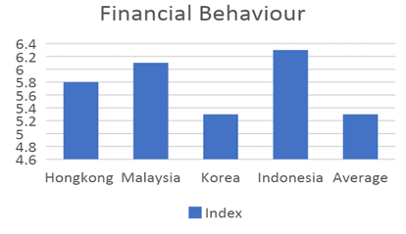 | 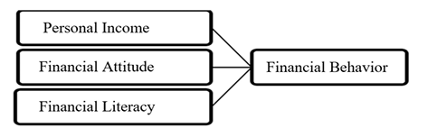
Figure 2.1: Financial Behaviour  Source: (International Survey of Adult Financial Literacy, 2020) | Figure 2.2 Financial Research Framework  Source: (International Survey of Adult Financial Literacy, 2020)

New educational strategies emerge because young adults face such hurdles to gaining financial literacy knowledge. Stanford University started an educational venture to include a personal finance curriculum through modern technological tools and collaborative methods for financial knowledge evolution. These initiatives aim to give Gen Z members the necessary knowledge and skills that they need to manage modern financial structures effectively (Atkinson & Messy, 2012b).
Research by the National Endowment for Financial Education (NEFE, 2022) demonstrates that the main concern of Gen Z is attaining financial independence and making investments via stocks and cryptocurrency, although these young adults struggle to learn fundamental financial concepts. Research results suggest that financial education ought to provide specific information about contemporary financial matters, such as debt management and digital assets, and credit establishment.
The OECD (2020) conducted real-world examinations across multiple nations, which exposed that Gen Z educational students at all educational levels experience troubles with adapting their learned financial concepts into concrete financial abilities. Although quiz-style questions regarding inflation and savings received good results from students, they faced challenges with budgeting specific expenses and selecting suitable financial options. The OECD proposed to include practical financial simulations alongside mobile-based budgeting tools as educational additions to school curricula for better gap resolution.
Academic research performed by Gudmunson and Danes (2011) demonstrated how parental involvement in financial socialization during childhood forms the money habits of Gen Z members. The members of this generation have seen how the 2008 recession and the COVID-19 pandemic affected finances, yet they maintain their careful saving habits while stressing about their financial future because of high education expenses and unstable employment opportunities.
2.2.1 Budget
Creating an allocation system for how money is distributed to expenses, as well as savings and debt repayment activities, defines budgeting processes. A budget operates as an essential framework that allows people to observe their financial behaviors while maintaining budgeted amounts to reach their financial targets. Budgeting works effectively when people track their income and expenses together with expense categorization to modify their spending behavior for preventing overspending (Fernandes et al., 2014b). Financial success improves through budget implementation since it helps people take responsibility while enabling better saving for upcoming needs.
2.2.2 Saving
Setting aside a part of present-day income to use later in time constitutes saving. Savings give people protection against unexpected costs and provide the resources needed to reach temporary aspirations and establish investment strategies. Investing money routinely establishes financial stability and enables individuals to handle unexpected costs using funds that are debt-free. Understanding financial concepts enables people to develop effective saving behaviors since those who comprehend financial principles better tend to value saving more and establish wealth-building methods (Fernandes et al., 2014b).
2.2.3 Investing
Resources, especially money, are distributed through investments to achieve profits or income. Each consumer needs to select investment tools from among stocks, bonds, mutual funds, and real estate, depending on their tolerance for risk, combined with the duration of their investment and their specific financial targets. The process of investing forms the core of both financial development and retirement preparation because correctly chosen investments produce returns better than inflation rates, thus strengthening purchasing power progressively. A deep understanding of investment principles became essential because investments bring uncertain risks, which need informed choices to prevent losses (Fernandes et al., 2014b).
2.2.4 Debt Management
The goal of debt management is to use borrowed money in an optimal way for debt control and financial stability purposes. People must read credit product regulations, then pay bills on time, while developing methods to balance existing debts effectively. Through proper debt management, people achieve good credit scores, reduce stress levels that enable them to save and invest (ISSN 2746-5667 (Online) | Proceeding International Conference on Business and Social Science | the ISSN Portal, n.d.-b). A person needs financial knowledge for proper debt management because it shows them how to explore different credit choices while establishing methods to handle and repay debts in a responsible way.

2.3 Previous Works of Personal Finance App
Table 2.1 Research Paper Comparison
SOURCES | RESEARCH TOPIC | METHODOOGY | FINDINGS | LIMITATIONS | FUTURE RESEARCH
Talasila (2024) | AI in budgeting apps & savings behavior | Survey + case study + pilot testing (1000 users) | AI improved savings by 15% monthly | Pilot-scale, short duration | Scalability & long-term engagement
Agarwal et al. (2024) | NLP-based personal finance assistant | NLP modeling + usability testing | Effective for goal-setting, less so for emotional triggers | Lacks real-time banking integration | Add emotional finance triggers
Stefanov et al. (2024) | Mobile budgeting & visualization | Survey + prototype testing | Visualization improved spending awareness | Focused on Android users only | Cross-platform implementation
Mok (2022) | Finance chatbot for goal-based saving | Case study + interviews | Chatbot increased engagement, especially among Gen-Z | Needs financial education features | Integration with gamified learning
Lau et al. (2023) | Gen-Z preferences in budgeting apps | Survey of 500 Gen-Z users | Personalization & rewards are critical | Lacked diverse age groups | Add financial nudges & education
Singh et al. (2023) | AI pattern recognition in budgeting | ML algorithms on user datasets | Detected overspending trends with 82% accuracy | Requires more behavioral layers | Integration with emotion-based data
Wu & Li (2021) | Expense tracking effectiveness | Quantitative study of app users | Consistent tracking correlated with debt reduction | Self-reported data | Automate spending categorization
Stanford (2023) | Financial literacy app curriculum | Pilot university implementation | Boosted budgeting knowledge by 32% | Campus-only context | Broader deployment in high schools
Hean et al. (2024) | Can LLMs help in finance coaching? | LLM testing on queries | Accurate for 78% of finance tasks | Not trained on live bank data | Real-time API integration
Bera & Bandyopadhyay (2022) | Fintech usability in savings goals | Mixed methods | Visual goal trackers improved saving intent | Small user group | Longitudinal studies
Deep & Chawla (2023) | AI for predictive budgeting | ML prediction framework | High accuracy in bill prediction | No emotional or behavioral model | Hybrid with psychological models
Choi et al. (2022) | Young adults' finance app use | Survey of 600 participants | Peer-sharing increased financial learning | Lacks AI automation | Add social AI feedback
Adewumi et al. (2023) | Coaching apps for underserved users | Field deployment + feedback | Financial stress lowered, higher confidence | Internet access barrier | Offline functionality
Huang & Chen (2023) | Cross-cultural finance app behavior | Comparative study (Asia/US) | Personalization needs vary by region | English-only app content | Multilingual AI coaching
Sarker et al. (2021) | Gen-Z and gamified finance apps | App experiment with/ incentives | Gamification increased retention by 24% | Focused only on university students | Real-world financial impact
Varghese et al. (2023) | Chatbot feedback in budgeting | A/B testing chatbot vs static UI | Chatbot users are 2x more engaged | Limited financial domain knowledge | Expand the chatbot’s financial scope
Fogg et al. (2022) | Behavior triggers in finance apps | Psychology + tech framework | Micro-triggers boosted habit formation | No spending data used | Add real-time spending cues
Kwon et al. (2022) | Digital wallets & budgeting | Observational study | Wallet-linked budgeting showed more accuracy | Banking API limitations | Standardize APIs across banks
Zhang et al. (2023) | Real-time nudges in finance apps | Experimental nudge model | Reduced overspending by 17% in the test group | Short-term study window | Long-term nudge fatigue testing
Ismail & Rahman (2024) | Islamic finance budgeting app | Prototype + user feedback | Interest-free savings planning was popular | Limited regional focus | Expand to multi-faith finance coaching

2.3.1 Current Concept of Creating Personal Finance & Budgeting Application
The present budget recording approach is done manually in a conventional manner. Some individuals, particularly the elderly, still utilize pen and paper to keep track of everyday transactions. Children tend to frighten their elders, therefore, the custom may be passed down to their children (Gargano & Rossi, 2024b). Using software or digital gadgets to track personal finances may be unfamiliar to some generations. Traditional transaction monitoring often uses pen and paper. Tracking personal costs regularly might be inconvenient as it requires carrying extra goods with them everywhere (Gargano & Rossi, 2024b). Keeping track of spending might be difficult due to limited storage space in pockets or handbags. Consistently documenting all transactions may be discouraged due to automatic responses that prevent financial discipline.
Another option for tracking personal costs is to use an old-school spreadsheet. The spreadsheet categorizes expenses by respective area and displays them in a tabular format. Using a spreadsheet for expenditure tracking has certain advantages (Gargano & Rossi, 2024b). Using a custom-designed spreadsheet can help users manage their finances, give them more control over the layout and content, and provide community support for beginners. The spreadsheet budget tracking method is effective, but it lacks the willpower to update frequently, making it unattractive to many (Gargano & Rossi, 2024b). Users often forget transaction details, making it difficult to track transactions. Despite having thousands of templates, the system lacks accessibility on modern smartphones. A personal finance and budget tracking system is proposed, designed with modern mobile development frameworks in mind. The system aims to encourage personal finance discipline among the public, making it convenient and easy-of-mind. This system aims to improve the accessibility of financial management and encourage more people to adopt financial discipline (Gargano & Rossi, 2024b).
Budgeting involves complex decision-making, which can be challenging for individuals without the necessary knowledge and experience. Recommender systems help users navigate the vast array of choices when making spending decisions. Knowledge-based recommender systems are chosen as the suggested approach, as they rely on existing knowledge or rules about user needs and item functions (Gargano & Rossi, 2024b). These systems offer advantages in data selection and security, as they provide recommendations based on the user's previous record, making them user-independent. Knowledge in the knowledge base is referenced when the system encounters a new recommendation problem. The most common technique in knowledge-based recommender systems is case-based reasoning, which uses previous cases to solve current problems (Gargano & Rossi, 2024b).
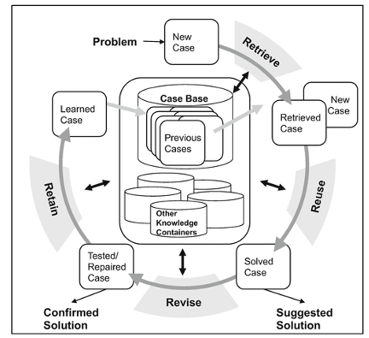
Figure 2.3: Flow Chart of Case-Based Reasoning
Source: (Gargano & Rossi, 2024b)

2.4 Review Existing Financial Application
2.4.1 eExpense: A Smart Approach to Track Everyday Expense
S.A. Sabab et al. presented an app for tracking costs on cellphones. The suggested application uses Optical Character Recognition (OCR) to extract textual information, eliminating the requirement for human input. As a result, this function enables customers to track their costs by scanning invoices or receipts (Personal Finance Management System - UTAR Institutional Repository, n.d.-b). This program also records SMSs from the user's savings accounts to record their revenue.

System Overview
The app is separated into four main sections: debit, credit, balance, and history. The debit part records all expenses, whereas the credit part records all revenue.
A. Debit
Users can enter the debit data manually or scan the money receipt using their phone's camera. Users can modify any of the retrieved information to correct any errors before storing the entries (Personal Finance Management System - UTAR Institutional Repository, n.d.-b).
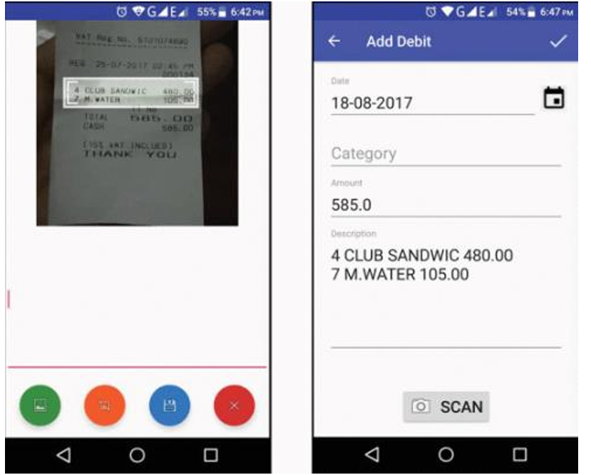
Figure 2.4: eExpense’s Debit
Source: (Personal Finance Management System - UTAR Institutional Repository, n.d.-b)

B. Credit
The system will scan all the users' phone messages, detect any bank communications concerning any credit transactions, and preserve the information. Users can opt to manually enter their income into the program (Personal Finance Management System - UTAR Institutional Repository, n.d.-b).
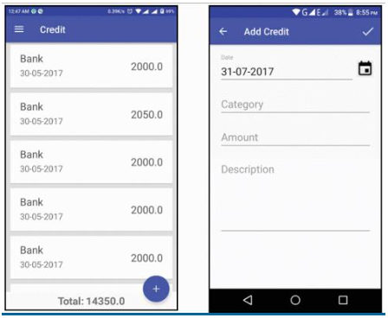
Figure 2.5: eExpense’s Credit
Source: (Personal Finance Management System - UTAR Institutional Repository, n.d.-b)

C. Balance
Users may examine their debit and credit data in the 'balance' interface, which is shown in pie charts like Figure 3 below. Users can select between monthly and annual balances. The pie chart will display the total estimation from all user-created categories, such as food, grocery, and recreation (Personal Finance Management System - UTAR Institutional Repository, n.d.-b).

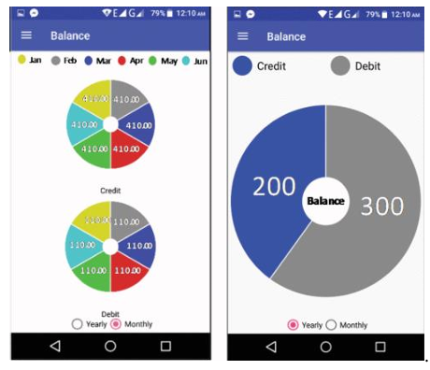
Figure 2.6: eExpense’s Balance
Source: (Personal Finance Management System - UTAR Institutional Repository, n.d.-b)

D. History
Users may utilize the calendar interface to choose a date and view the total amount of expenses for that date, as illustrated in Figure 4 below. The users can then verify the category of expenses for that date.
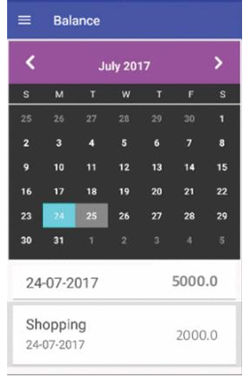
Figure 2.7: eExpense’s Expense History
Source: Personal Finance Management System - UTAR Institutional Repository, n.d.-b

Conclusion
Finally, eExpense decreased user input by utilizing Optical Character Recognition (OCR), which enabled users to enter their costs by scanning their invoices or receipts. The program also monitors the user's SMS to record their revenue. However, eExpense lacks key capabilities that help users budget, create financial goals, and plan for retirement. While eExpense makes cost tracking easier, it falls short of providing customers with insights and assistance for their financial management needs.

Strengths
- eExpense uses OCR to automatically input the expense record into the system when users scan their bills.
- eExpense tracks SMS to record users’ income automatically.
Limitations
- eExpense lacks features that help users in budgeting.
- eExpense did not have guidance for users on expenses.
- eExpense did not have the features that enable users to create financial goals and retirement plans.

2.4.2 Wallet: Budget Planner Tracker
Wallet is a smartphone application for tracking expenses that is available on Google Play. This program offers a variety of spending tracking features. One of the key aspects is bank synchronization (Personal Finance Management System - UTAR Institutional Repository, n.d.-b). This feature allows users to sync their bank accounts with the program. So, all online banking transactions are automatically logged in the program. As a result, the program required less user input (Personal Finance Management System - UTAR Institutional Repository, n.d.-b).

System Overview
A. Manual Input Expense
This software allows users to manually input their expenses. They can specify the type and amount of spending to include in the record.
B. Record
The program gives several ways to show the records. For example, keep track of your expenses for today, this week, this month, this year, and any specific day.
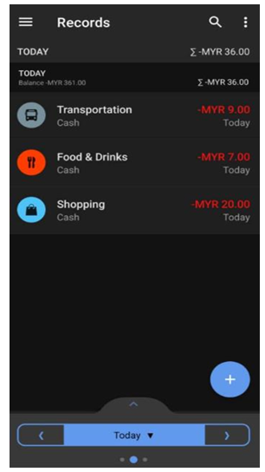
Figure 2.8: Wallet’s Expense Records
Source: (Personal Finance Management System - UTAR Institutional Repository, n.d.-b)

C. Budgets
The budget tool allows users to define a budget for a certain period, such as one week, one month, and so on. If users attempt to overspend, the program will inform them with a notice.
D. Goals
This software allows users to define financial goals. For example, if users wish to save money for a phone, they may create a new goal and provide the goal name, target amount, and so on. After that, users may click the objective and enter the amount of money saved. If they have successfully saved the required amount of money, they can mark the objective as achieved.

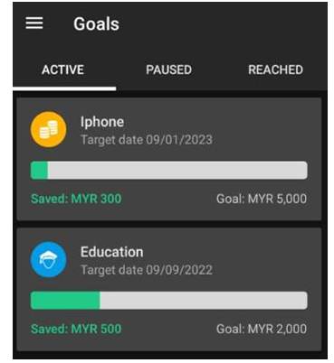
Figure 2.9 Wallet’s Goals
Source: (Personal Finance Management System - UTAR Institutional Repository, n.d.-b)

E. Reminder
This software has a reminder tool for budgeting, anticipated payments, and debts. This reminder tool is designed to remind and regulate users from overspending on their budget. Furthermore, it notifies users of upcoming payments such as power bills and rental fees. The app will also remind users to record their daily spending at 20:00. Users can enable or disable all these reminders.
F. Statistics
Wallet collects expense data and gives customers a variety of insights, including cash flow, cash flow trends, spending patterns, and much more. The numbers below depict the facts and insights supplied by Wallet:
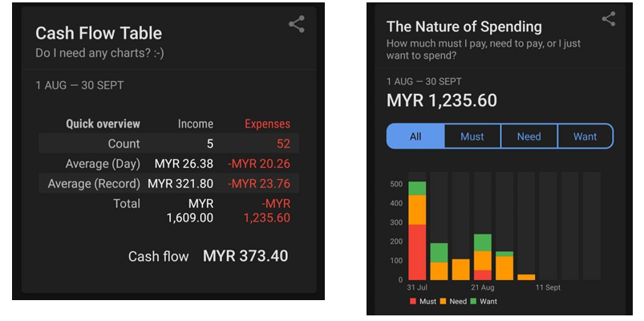
Figure 2.10 Cash Flow Table and Nature of Spending from Wallet
Source: (Personal Finance Management System - UTAR Institutional Repository, n.d.-b)

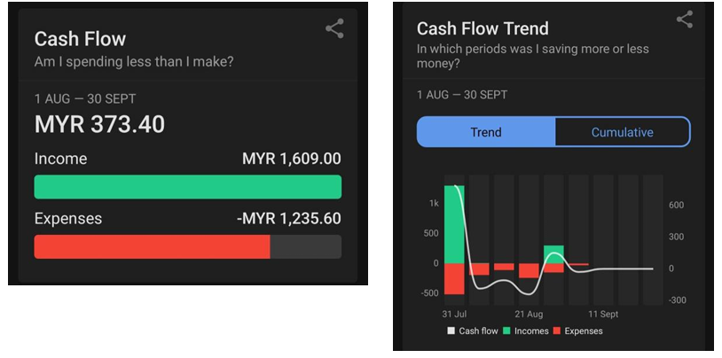
Figure 2.11 Cash Flow and Cash Flow Trend from Wallet
Source: (Personal Finance Management System - UTAR Institutional Repository, n.d.-b)

As shown in the figures above, Wallet provides the feature to efficiently process and analyze users’ expense data to generate various statistics and insights.

Conclusion
This application provides many useful functionalities and an interactive user interface to motivate users to use their application and control their expenses.

Strengths
- Users may manage their funds effectively with several functions.
- Track bank transactions with synchronization.
- Effective user interface.
- Users may gain insights using the statistics function.

Limitations
- Did not provide a spending guide for users.
- Did not have a retirement planning feature.
2.4.3 Monefy – Budget & Expenses App
Monefy is a spending monitoring tool designed to assist users in reaching their financial objectives (Personal Finance Management System - UTAR Institutional Repository, n.d.-b). This application's main aim is to give users an easy-to-use interface for recording their spending.

System Overview
A. Data Synchronization
One of the application's key merits is its ability to synchronize data across various devices. If users have numerous mobile devices, they can share budget and spending tracking information (Personal Finance Management System - UTAR Institutional Repository, n.d.-b). For example, if users update or remove a new record, the changes will be reflected across all synced devices. Users must pay the 'premium' to use this function.
B. Expense Recording
This application enables users to record their expenses easily.
C. Chart
Users can review their prior spending on the chart below. Viewing the presented chart allows users to get a true idea of their spending and revenue.
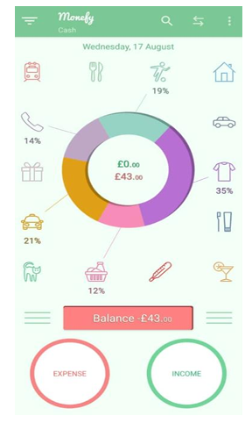
Figure 2.12: Monefy’s User Interface
Source: (Personal Finance Management System - UTAR Institutional Repository, n.d.-b)

Conclusion
This software provides basic features to assist users in managing their finances.

Strengths
- Users may quickly record and view their spending.
- Synchronizing data across numerous devices.

Limitations
- Lacks financial management suggestions and procedures.
- Limited functionality.

2.4.4 Spending Tracker
Spending Tracker is another cost-tracking software available on the Google Play Store. This program allows users to effortlessly enter their spending into the system. All cost data may be divided into numerous categories, such as food, petrol, etc. Users can also establish a new category for their expenses (Personal Finance Management System - UTAR Institutional Repository, n.d.-b). The software allows users to enter their spending and money into the system. The system will then display the overall amount of revenue and cost, as seen in Figure 8 below. Users can also enter their costs into the repeated information (Personal Finance Management System - UTAR Institutional Repository, n.d.-b). For example, customers can enter their monthly rental amount into the recurring information, and the system will add the transaction to the record every month.
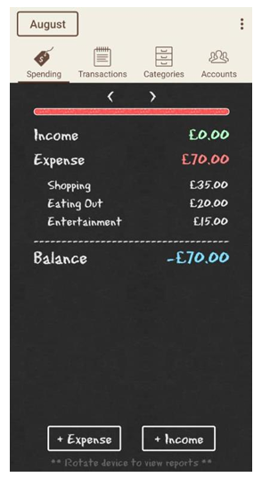
Figure 2.13: Spending Tracker’s User Interface
Source: (Personal Finance Management System - UTAR Institutional Repository, n.d.-b)

The app includes basic spending monitoring features and is comparable to Monefy. The software includes basic functionality like logging and viewing expenditures.

2.4.5 Belanjawanku
Belanjawanku is a spending monitoring software intended exclusively for Malaysians who live in the Klang Valley and other chosen areas around Malaysia (Personal Finance Management System - UTAR Institutional Repository, n.d.-b). Based on studies conducted by the Social Wellbeing Studies Centre (SWRC), Belanjawanku offers users anticipated monthly expenditures for their cities. Belanjawanku not only provides typical spending recording and monitoring, but it also includes budget advice and financial management resources.

System Overview
A. Spending Guide
Based on SWRC research, Belanjawanku creates a tailored spending guidance and budget for each user based on their city, marital status, method of transportation, and other criteria. The figure below depicts the suggested minimum monthly spending for each category (Personal Finance Management System - UTAR Institutional Repository, n.d.-b).
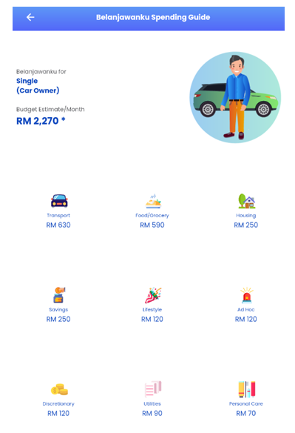
Figure 2.14: Belanjawanku’s Spending Guide
Source: (Personal Finance Management System - UTAR Institutional Repository, n.d.-b)

B. Tips and Guidance
Belanjawanku offers a variety of financial management suggestions, including budgeting, spending, saving tactics, and automobile affordability.
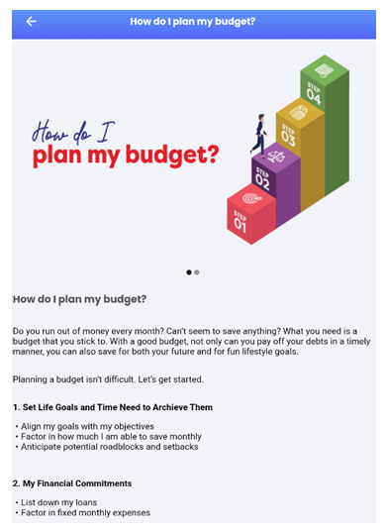
Figure 2.15: Belanjawanku’s Tips and Guidance
Source: (Personal Finance Management System - UTAR Institutional Repository, n.d.-b)

Conclusion
In brief, Belanjawanku offers Malaysian consumers a tailored spending plan, budgeting tools, and helpful financial management advice. In addition, Belanjawanku's user-friendly design allows users to simply enter and manage their costs.

Strengths
- Generate a personalized spending guide for users in Malaysia.
- Provide tips on financial management.
Limitations
- Did not have the option for users to modify their spending guide and budgets.
- Did not have a feature to help users in retirement planning.

2.4.6 Comparison Among the Reviewed Systems
Table 2.2 Reviewed System Comparison
Existing Systems | Spending Guide/Budget | Retirement Plan | Financial Goals | Expense Analysis
Wallet | × | × | ✔ | ✔
Monefy | × | × | × | ×
Spending Tracker | × | × | × | ×
eExpense | × | × | × | ×
Belanjawanku | × | × | × | ×

According to the chart above, among the assessed systems, only Belanjawanku provides tailored spending advice for each user. All the systems that were assessed lacked a retirement planning capability. Except for Wallet, none of the assessed systems had a feature that enabled users to set financial objectives. Finally, except for Wallet, none of the previous systems provided analysis or insights on user spending.

2.5 Review Existing Techniques for Financial Management
2.5.1 The 50/30/20 Budgeting Method
According to the Personal Finance Management System - UTAR Institutional Repository (n.d.-b), the rising cost of living in Malaysia is a major concern for the majority of Malaysians. To address this issue, this article proposes the 50/30/20 budgeting method, which divides our monthly earnings into three categories.
- Needs – 50%
This refers to fixed expenditures that we cannot avoid, such as room rental, energy bill, internet subscription, etc. According to the essay, if our needs reach 50%, we should reassess our spending habits. For example, we can lower our internet subscription or use less power (Personal Finance Management System - UTAR Institutional Repository, n.d.-b).
- Wants – 30%
Wants are non-essential costs that are not strictly required. Examples include entertainment, clothing shopping, dining out, and so forth. As a result, by adhering to the 50/30/20 guideline, we may still live a fulfilling life (Personal Finance Management System - UTAR Institutional Repository, n.d.-b).
- Savings – 20%
The remaining 20% is for saving, which will help us attain our financial objective. By saving 20% of our monthly income, we may establish a sound savings plan, including an emergency fund and financial plan (Personal Finance Management System - UTAR Institutional Repository, n.d.-b).
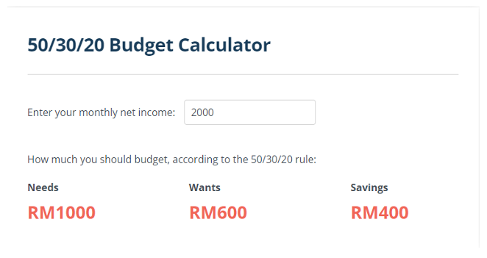
Figure 2.16: Budget Calculator
Source: (Personal Finance Management System - UTAR Institutional Repository, n.d.-b)

As seen in the picture above, if our monthly income is RM2000, we may spend RM1000 on necessities, RM600 on desires, and RM400 on savings. The 50/30/20 rule is a straightforward yet effective way to manage our spending (Personal Finance Management System - UTAR Institutional Repository, n.d.-b).

2.5.2 The Emergency Fund Rule
Personal financial advisors at present endorse the Emergency Fund Rule, advising individuals to save emergency cash equivalent to their monthly living costs from three to six months in dedicated emergency savings (“The Improvement of Financial Literacy and Digital Payment Behavior in Generation Z: A Literature Review,” 2024). Emergency funds act as a protective measure that lets people avoid excessive financial pressure and thus prevents them from taking on costly emergency loans. People seeking to develop emergency funds should employ automated account transfers as their main saving practice for financial stability (“The Improvement of Financial Literacy and Digital Payment Behavior in Generation Z: A Literature Review,” 2024). The emergency fund acts as the primary element in financial education since organized training teaches people to build a stable safety system through regular small savings.

2.5.3 The Debt Snowball Method
The Debt Snowball Method enables people to create a debt repayment approach that first extinguishes small debts, then addresses bigger debts. People can achieve rapid debt payoffs through this strategy, which produces motivating power to reach their debt repayment objectives. Research shows that debt payers holding lower outstanding debt balances succeed in eliminating their debts. Although the debt reduction method helps with debt liberation, it offers less efficient interest payment compared to other methods (Faulkner, 2015).

2.5.4 The Diderot Effect
The Diderot Effect occurs when customers purchase one product that later drives them into multiple additional purchases that result in unwanted financial debt. Denis Diderot became associated with this consumer pattern following his receipt of an expensive robe that resulted in a financial downfall as he acquired other items (“The Improvement of Financial Literacy and Digital Payment Behavior in Generation Z: A Literature Review,” 2024). People need to exercise mindful spending due to this behavioral pattern that results in new acquisitions, which create further expenses, which harm their financial stability.

2.5.5 The Latte Factor
The Latte Factor explains how repetitive everyday typical expenses like buying coffee develop into significant money that threatens our lifetime financial goals. Financial expert David Bach made this idea popular through his writings because he showed people how deliberately spending less on small desires will create big financial breakthroughs. When Generation Z adopts conscious purchasing habits alongside the power of compound interest, they gain increased abilities to construct wealth (“The Improvement of Financial Literacy and Digital Payment Behavior in Generation Z: A Literature Review,” 2024).

2.5.6 The Rule of 100 for Retirement Savings
The Rule of 100 serves as an assessment method to determine how stock and risk-tolerant investments should be split throughout senior adulthood. Users need to determine stock percentages by subtracting their age from 100 before assigning bond weights to unused amounts. Following the Rule of 100 people aged 30, need to distribute their investment into 70% stocks, together with 30% bonds (“The Improvement of Financial Literacy and Digital Payment Behavior in Generation Z: A Literature Review,” 2024). This investment approach starts with a high-risk allocation for growth, then transitions portfolios to risk-reduction by adding more stability through time until the retirement date.

2.5.7 The Time Value of Money
Any financial resource possesses greater value when paid today compared to the same amount set to arrive at a later period because of its ability to generate earnings according to Time Value of Money principles. The ability to earn investment returns enables money to hold greater worth in the present day than in the future, which makes it suitable for determining interest payments and designing financial strategies (Imawan et al., 2025). Financial institutions require Time Value of Money knowledge to make funding decisions because it proves that funds received before their intended date possess higher value than their future worth.

2.5.8 The Rule of 72
Through annual steady growth rates, the Rule of 72 enables easy prediction of how long it takes for investments to double in value. The Role of 72 determines investment doubling time through dividing 72 by the yearly interest rate, according to Faulkner (2015). With 6% annual returns, it takes approximately 12 years for the principal to double based on Rule of 72 calculations. The Rule of 72 enables investors to quickly estimate compound interest outcomes through annual interest rate adjustment to see their investment growth possibilities (Imawan et al., 2025).

2.5.9 The Behavioral Biases Theory
The Behavioral Biases Theory studies mental elements together with fundamental prejudices that cause non-rational financial decisions from people that defy fundamental economic models. Three standard biases exist among individuals who demonstrate overconfidence by overestimating their prediction capability and loss aversion by choosing loss avoidance over equivalent gains and herd behavior from following others in bigger groups (Faulkner, 2015). Investment decisions that involve psychological biases causing poor financial choices remain unexplained to neuroscientists and psychologists since logical thinking takes a backseat during such investments. Evaluation of cognitive biases leads to the development of methods fighting their effects, which produces better financial choices and better investment outcomes.

2.5.10 The Debt-to-Income Ratio (DTI)
The Debt-to-Income Ratio (DTI) calculates the monthly debt payments through gross monthly income to create a percentage ratio. A fundamental indicator of fiscal wellness strengthens through the ratio because it displays debt costs about overall income (Faulkner, 2015). DTI assessment provided to lenders enables them to determine the debt servicing abilities of borrowers through their monthly debt obligation payments, but lower-than-average DTI ratios indicate stronger economic stability and reduced financial risks. Having a high DTI ratio implies that the borrower has probably exhausted their maximum borrowing capacity, which poses a greater risk to their fiscal ability to make new debt payments. Financial stability requires control over Debt-to-Income ratios, which simultaneously determines credit conditions, together with credit service accessibility.

2.5.11 The Sunk Cost Fallacy
A person will continue to support decisions that accumulate investment by using the Sunk Cost Fallacy even when signs indicate future setbacks. People make incorrect choices because they desire to defend their investments, but also fall prey to this mistake (Imawan et al., 2025). Stockholders tend to maintain their declining stock positions because they originally spent considerable amounts, even though analysts predict decreasing value. Business direction needs both detection and remedy of sunk cost fallacies for objective financial decisions, since previous investments should not impact business direction (Faulkner, 2015).

2.6 Findings and Outcomes Summary
2.6.1 Existing Financial Application Summarization
Almost all previously reviewed financial applications have interactive interfaces to enable easy expense recording at their core, yet the most popular tools remain eExpense, Monefy, and Spending Tracker. The existing applications fall short because they do not include proper guidelines for budget management. Such applications allow users to track expenses, yet they lack features that support budget planning.
Belanjawanku presents itself as the only application reviewed to offer SWRC-based minimum monthly budgeting for Malaysian city residents. Within this feature, users gain the ability to schedule household budgets, which makes them ready to handle unexpected situations.
Wallet functions as a distinctive financial application that offers several functionalities to assist with user financial management. Users can access expense processing through this system to receive valuable information about past costs. The system shows users how they spend their money through this capability. The graphic in Figure () demonstrates how the program sorts user expenditures between essential needs (Must) and necessary items (Need) as well as nonessential items (Want).
Financial management includes retirement planning as its fundamental pillar among all other aspects, including in Malaysia. None of the assessed applications includes a feature for retirement planning. The existing pension crisis in Malaysia grew worse after many Malaysians withdrew savings from their retirement accounts during the COVID-19 pandemic. Therefore, retirement planning features have become more essential now than ever.
2.6.2 Existing Technique on Financial Management Summarization
People across the world consider the 50/30/20 budgeting rule to be an established financial management system. This system serves as both user-friendly and secure in managing payment expenses.
The retirement plan calculators demonstrate identical core processes that assist people in determining retirement needs based on their savings total, alongside regular contributions, to produce valuable retirement planning data.
The financial management concepts outlined in theories direct effective approaches to handle personal finance requirements. Under the Emergency Fund Rule, individuals should save money equivalent to three months up to six months of their expenses when starting the Debt Snowball Method with smaller debts to maximize their motivational drive. Consumers affected by Diderot Effect and Latte Factor end up spending needlessly on unwanted things, yet their shopping becomes limited, and they earn small financial savings. Retirees who use the Rule of 100 can determine proper investment levels that match their age through a combination of Time Value of Money, with the Rule of 72 revealing that early investment initiation results in long-term financial growth. Studies on Behavioral Biases Theory from scientists reveal how mental characteristics affect investment behaviors through analysis of biases, including loss aversion and overconfidence, and additional human misunderstanding patterns. Businesses need to avoid relying on sunk costs to make disadvantageous current decision-making processes in accordance with Sunk Cost Fallacy findings, while the Debt-to-Income Ratio serves as the key measure for creditworthiness evaluation.

CHAPTER 3: METHODOLOGY
3.1 Overview
Research methodology defines the route through which researchers formulate their problems, purposes, and how results will be achieved from the data obtained (Sk et al., 2020). This chapter outlines and establishes both the project approach and the technique that is used in building the enhanced bugdeting app, focusing on a structured process to meet the needs of Gen Z users. Starting from the design phase of the project features, the development stages, selected tools and technologies, and describes the essential functional and non-functional requirements of the app construction. Additionally, it highlights the project milestones, Gantt charts, and user feedback loops, which guarantee the app provides both security and usability and high performance. Users and technical aspects are integrated through this methodology to develop a flexible and engaging budgeting solution with motivational features.

3.2 The Project Design and Development Process
The development of the enhanced budgeting app started with thorough research, along with discussions, which led to defining project direction, scope, and requirements. The Agile methodology served as a guide to direct the development process by supporting flexible development with iterative approaches (Pargaonkar, 2023). The Software Development Life Cycle (SDLC) frames the project phases as follows: Planning, Requirement Analysis, Design, Implementation, Testing, and Maintenance (Shankar & Chaudhari, 2023). This approach ensures that the app was designed to satisfy the needs of Gen Z users while enabling ongoing improvement based on user input. The app reached its goals of user-friendliness, combined with security and top performance, through the execution of every development phase.

3.2.1 Planning
The Planning phase focused on defining the project’s objectives, goals, and scope. The project started by selecting a proper FYP title requiring extensive research of Personal Finance Management (PFM) systems from both journals and websites, as well as expert input and the project supervisor's guidance. This study established the requirement for an age-appropriate budgeting system designed specifically for Gen Z individuals. The project received its official title, after which a comprehensive plan outlined project objectives as well as resource use and time requirements, and essential progress markers. The project team used a Gantt chart to monitor progress so they could maintain their schedule. To keep the project on track and ensure the project remained on schedule, this phase also involved making a Gantt chart that monitors project milestones from initial planning to testing and maintenance.

3.2.2 Requirement Analysis
In the Requirement Analysis phase, functional and non-functional requirements were gathered and refined to guide the app’s development. Functional requirements included key features such as user authentication, transaction management, budget tracking, personalized goal setting, and streak tracking. Non-functional requirements were defined to ensure high performance, robust security, and seamless user experience. The application leveraged SQLite for managing databases efficiently, while password hashing became the security measure used to protect user data. Supervisor discussions were ongoing during this phase to guarantee that the application met every requirement of Gen Z users. The documented requirements became the basis for designing the app before its actual development phases began.

3.2.3 Design
The Design phase transformed requirements into technical specifications to guide the mobile app development. The design utilized the Model-View-Controller (MVC) pattern to separate the app’s logic, user interface, and control flow, enhancing maintainability and scalability. The application system architecture adopted a client-server structure, which enabled back-end operations for data storage through transactions and user profiles while presenting an interactive and user-friendly frontend to users. The user interface development used ipywidgets to access its interactive features for buttons and dropdowns, and text inputs, which resulted in a very responsive and user-friendly interface. The design procedure led to wireframe development alongside UX mockup creation to create an attractive interface that Gen Z users would find easy to navigate. The development of the database scheme took place in this phase to determine how the application would store and access user information, along with transaction records and budget details.
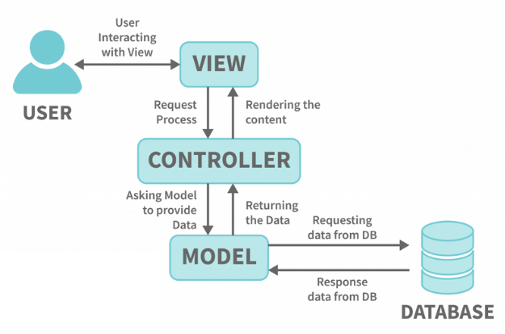
Figure 3.1 MVC Architecture Basic Data Flow
(MVC Architecture - Detailed Explanation, 2022)

3.2.4 Implementation
The application was created during this Implementation phase with ipywidgets for the frontend and Python for the backend. The backend handled the app’s logic, including user authentication, transaction management, and database operations, while the frontend was designed to be interactive and user-friendly. The app used SQLite for database operations to store and retrieve user data, together with budgets and transactions, effectively. The developers conducted iterative development while receiving continuous input from users and our supervisor to enhance both the app interface and its features. The implementation included real-time account balance updates, together with budget tracking and transaction tracking, streak tracking, and personalized goal management features based on the specifications in the prior design phase.
3.2.5 Testing
The Testing phase involved thorough verification to ensure the app’s functionality, security, and user experience were up to the desired standards. A testing process checked individual components like user registration, along with transaction management, to verify their operational correctness. The testing checked for complete app functionality by making sure backend and frontend elements operated properly together. 10 Gen Z users aged between 18 to 23 years old participated in the User Acceptance Testing (UAT) to provide input on the app's usability, functionality, and user engagement. The feedback obtained during testing became the foundation for app improvements that included better user interface design and bug correction.
3.2.6 Maintenance
This maintenance phase involved monitoring the app for any issues and making necessary updates. The development team solved all identified issues with bugs and performance problems straight after the release. Regular user input shaped modifications to both app features, along with methods to boost user involvement. Regular maintenance activities included making updates, which ensured the app stayed secure and user-friendly while maintaining compatibility with Gen Z user demands.

3.3 Tools and Technologies Used
The enhanced budgeting app development process involved picking appropriate tools alongside technologies that precisely matched the project's functional needs and end goals. Flexible and scalable interactive technologies were chosen during the development process to create a personalized, high-performing budgeting solution for Gen Z users.

3.3.1 Programming Languages and Libraries
The primary language for developing the app backend was Python, which allows developers to integrate different libraries for quick development. At first, Jupyter Notebooks served as the development tool for prototyping, yet their storage and dynamic limitations led to a project switch to Google Colab. The transition to Google Drive brought more flexible data storage capabilities, which let users save information in a SQLite database. List of used libraries:
- SQLite3: Serves as the database platform to manage all application data functions, including user account storage and transactions, and budget documentation alongside other program information.
- ipywidgets: Create interactive UI components such as buttons, dropdowns, text fields, and progress bars, making the app more engaging for users. Very useful for building dynamic forms and managing user input.
- matplotlib: A tool for data visualization, especially for making charts (like pie charts and line graphs) that show users how much they spend and how far they've come in reaching their objectives.
- pytz: Tool to manage timezone calculations, thus maintaining timestamp accuracy throughout all app functions, especially during user logins from different geographic areas.
- re: Handle regular expression matching to validate essential inputs, including usernames and email addresses, and passwords.
- pandas: A crucial library for organizing and evaluating structured data, particularly helpful for managing transaction history and producing reports.
- datetime: Serves as a library for executing date-time operations that include streak calculation and the determination of the budgeting period's present day.
- dateutil.relativedelta: A tool for date calculation operations to handle time-based budgeting at daily, weekly, monthly, and yearly intervals.
- random: Displaying random motivational quotes to users.
- IPython.Display: Enables users to control the widget and output presentation to maintain seamless interaction within the Colab platform.

3.3.2 Hardware and Software
- Hardware
  - Laptop
    - Type: ROG Strix G531GU
    - Processor: Intel(R) Core(TM) i7-9750H CPU @ 2.60GHz, 6 Cores, 12 Logical Processors
    - Memory: 8.00 GB Installed Physical Memory (RAM)
    - Operating System: Microsoft Windows 11 Home Single Language, Version 10.0.22631 Build 22631
  - Smartphone
    - Type: Samsung Galaxy S22 Ultra
    - Processor: Qualcomm Snapdragon 8 Gen 1
    - Memory: 12GB (RAM)
    - Storage: Android 12 (One UI 4.1)
- Software
  - Research Tools
    - Google Scholar
    - Microsoft Word
  - Collaboration and Communication Tools:
    - Microsoft Teams
  - Development Tools
    - Google Colab
    - Jupyter Notebook
  - Cloud Storage
    - Google Drive
  - Project Management and Design Tools
    - Onlinegantt
    - Monday.com
    - Lucidchart

3.4 Project Milestone and Gantt Chart
Based on the SDLC described in the previous section, each project phase will have clearly defined deliverables. We present an extensive project schedule through this section, where deliverable accomplishment activities receive detailed depiction along with start and end date specifications. A Gantt chart will enhance the time management process through visual representation of project scheduling, which enables better progress tracking.

3.4.1 Gantt Chart
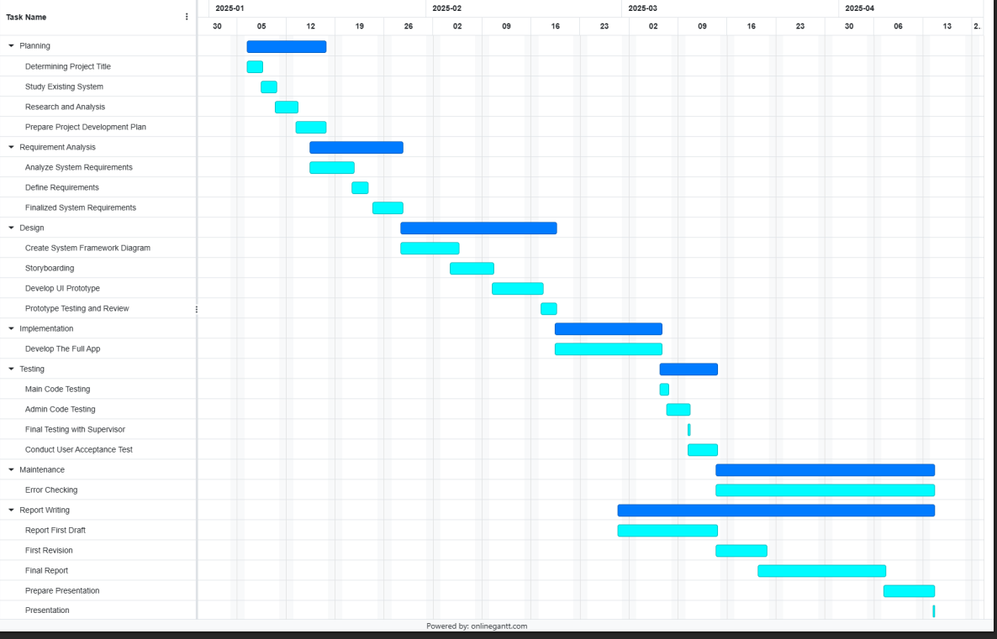
Figure 3.2 Gantt Chart

3.5 Functional and Non-Functional Requirements
The system requires features for user authentication, together with account and transaction management, while offering budgeting tools and category organization and subscription tracking, and visual data presentation. The application provides specific capabilities to let users handle their financial resources, monitor expenses, and navigate the system smoothly. The non-functional requirements of a system focus on performance and scalability alongside security features and usability, as well as maintainability of the system and data persistence (Khamayseh et al., 2022). The system requirements serve as essential elements to ensure fast performance, along with security measures combined with user-friendly design and easy maintainability, alongside data protection mechanisms and expanded user capacity.

3.5.1 Functional Requirements
Table 3.1 Functional Requirements
FUNCTIONAL REQUIREMENTS
NO. | REQUIREMENT | FEATURES | DETAILS
1. | User Authentication | User Registration and Login | - Description:  Users establish their accounts through system registration with a personal username along with email and password details. After registration, users need to verify their account through email to confirm its validity. Users who complete their registration successfully can enter the system through their username and password combination. User credentials undergo validation by the system before gaining access to the system. Users must establish passwords that contain uppercase letters together with numbers, along with special symbols, to achieve better security standards.  - Expected Outcomes:  Users obtain secure access to their accounts through a unique identity process through a protected login system. Authorized users remain the only entities who can access protected system features through this mechanism.
2. | Account Management | Account Creation, View, and Deletion | - Description:  The system allows users to establish several financial accounts to follow their account balance and expenses, but sets a maximum of 5 accounts per user. The financial accounts contain three key elements, which are the account name and balance, along with additional notes. Users can access their accounts to observe their account balances while handling their financial operations. Users can delete their accounts through the system, yet this functionality becomes limited if they maintain only one account active to guarantee continuous financial tracking.  - Expected Outcomes:  Users can handle their accounts by adding new ones and removing unwanted ones through system-imposed restrictions. A user restriction feature in the system prevents account clutter and always allows full visibility of financial activities.
3. | Budget Management | Create and Manage Budgets | - Description:  Users establish budgets through categorization and time parameters, and financial allocation amounts. Budgets exist for periods ranging from daily to weekly and monthly, and yearly durations. The system tracks budget spending through progress bars, which show how much budget has been utilized. The system notifies users through alerts when their financial spending reaches or surpasses their established budget amount to assist them with money management. Expected  - Outcomes:  Users can efficiently monitor their spending activities by comparing them against budget targets while making required changes. The system generates real-time notifications to users as they get near or cross their budget limits.
4. | Transaction Management | Add, View, and Delete Transactions | - Description:  Users can add transactions through the system, which requires them to define a category type along with a monetary value and account origin. Every financial entry receives a timestamp for precise documentation purposes. The system provides users with transaction history visibility through date range filtering tools for monitoring past financial activities. Users can remove transactions through the system when mistakes occur or duplicates exist to maintain their financial records.  - Expected Outcomes:  Tracking income and expenses is made simple for users by the ability to maintain an accurate record of their financial transactions. By eliminating erroneous transactions, the system guarantees that users can fix any mistakes.
5. | Category Management | Create, View, and Delete Categories | - Description:  Users of the system can make their categories for recording income and expenses. Users create a financial organization through categories that allow them to group transactions based on their nature. Users can save their created categories for future use because they are stored in the system across different sessions. Users can easily delete unneeded categories through the application, which helps maintain an organized financial record system by preventing category chaos.  - Expected Outcomes:  By establishing unique categories, users can customize their financial tracking and make it simpler to group their transactions. The system guarantees that users can efficiently manage categories, including eliminating ones that aren't needed.
6. | Streak Tracking | Streak Counter and Motivation | - Description:  User login streaks are monitored by the system to reward users who maintain regular application usage. An active streak occurs when users successfully access the application on each of their following days. Users get motivational text messages that adapt to their current streak status. Users can reach different streak milestones, starting from 5-day to 10-day to extended durations, and obtain corresponding badges to honor their regular app usage.  - Expected Outcomes:  The application uses rewards together with badges to drive users into consistent engagement by motivating their advancement. Through its streak recognition system, the platform encourages users to develop daily habits.
7. | Subscription Management | Add, View, and Delete Subscriptions | - Description:  Users can monitor their subscription expenses through a system that requires them to provide information about subscription names and categories, as well as payment amounts and billing dates. Users can check all their active subscriptions and track their subscription progress through a single system interface. Users can easily delete subscriptions from their tracking list through the system to maintain subscriptions that are currently relevant to them.  - Expected Outcomes:  Users can track subscription costs through an interface that asks for subscription name and category and payment information, and billing schedule. All active subscriptions and their progress can be viewed through a unified system interface by users. Through the system, users can effortlessly delete subscriptions from their tracking list to maintain subscriptions that still matter to them.
8. | Wishlist Management | Add and Fund Wishlist Items | - Description:  Users build a wishlist to organize future purchasing items. A wishlist contains items that show the name, together with the price information and notes. Users can track funding progress toward wishlist items because the system records contributions made to achieve item prices. The system displays real-time financing progress updates for each item through its progress bar so users can monitor their fundraising advancement.  - Expected Outcomes:  Users can set and manage their financial goals for desired purchases. The system enables users to track their progress and motivates them to reach their funding targets.
9. | Data Visualization and Reporting | View Transaction Trends and Generate Reports | - Description:  Users can create graphic reports of their financial activity, such as line charts that show transaction trends over time and pie charts that show income versus expenses. Users can make wise financial decisions by using the system to learn more about their spending habits. Users can examine periods in-depth by filtering reports by date range.  - Expected Outcomes:  Users gain better financial self-awareness through the visual presentation of trends and reports. The system enables users to base their financial choices on data through easily readable graphical financial reports.
10. | Notification and Alert | Budget and Subscription Alerts | - Description:  The notification system alerts users before they reach their budget threshold or exceed it. The system provides subscription charge date notifications, which alert users about upcoming payment obligations so they can take necessary action. The system provides alerts that notify users about major financial events to help them respect their financial constraints and handle recurring costs successfully.  - Expected Outcomes:  Help users avoid missing subscription payments and stay within their spending limits they receiving timely notifications. By sending out proactive alerts, the system gives users more control over their financial management.

3.5.2 Non-Functional Requirements
Table 3.2 Non-Functional Requirements
NON-FUNCTIONAL REQUIREMENTS
NO. | REQUIREMENT | FEATURES | DETAILS
1. | Performance | Fast and Responsive User Interface | - Description:  The system requires a speedy user interface (UI) that prevents delays when users perform any system interaction. All system actions, including account creation, transaction addition, budget updates, and navigation between sections (main menu, dashboard, and add transaction) should be completed within a few seconds. The system optimizes its database queries to manage user data efficiently throughout transaction and budget operations, and account maintenance tasks.  - Expected Outcomes:  Facilitates a smooth user experience by offering a smooth interface with no delays in task completion or navigation.
2. | Scalability | Handling Increased User Load | - Description:  The application needs to scale up its capacity when user numbers and transaction volumes, and stored data rise. The backend system must handle growing amounts of data and multiple users while maintaining optimal performance standards. The system must operate efficiently at any level of user numbers and transaction volumes.  - Expected Outcomes:  The application delivers high performance with reduced latency throughout user load growth to provide uninterrupted, smooth operation for all users.
3. | Availability | System Availability and Uptime | - Description:  The application needs to maintain operating times exceeding 99.9%. The system needs to provide minimal service interruptions through proper failover systems. Users need to receive advance notice about all planned maintenance downtimes. The system needs to provide rapid error recovery mechanisms to decrease unexpected downtime periods.  - Outcomes:  The app is highly available, and users can consistently access their data and perform actions like adding transactions, checking balances, or updating budgets without experiencing significant interruptions.
4. | Security | Data Protection and Encryption | - Description:  All user data consisting of personal information with passwords and financial information requires secure storage and transmission methods. All stored passwords must undergo hash processing before storage, and the system should encrypt sensitive data when it moves through networks, and when data remains inactive in the database. Users will have the option to implement multi-factor authentication (MFA) for improving system security.  - Expected Outcomes:  User data remains secure, ensuring privacy and protecting against unauthorized access and data breaches. Security protocols adhere to industry standards to safeguard sensitive information.
5. | Usability | Easy-to-Use Interface and Accessibility | - Description:  The system needs an easy-to-use interface that enables users, regardless of their technical proficiency, to effectively operate the application. Minimalistic design elements should characterize a clear interface. The application needs to serve users with disabilities through functionality that supports screen readers and additional accessibility features. All users, regardless of technical experience, should be able to use the application since its interface must deliver a seamless, user-friendly experience. A user-friendly system interface must show content by means of minimalistic design components in a straightforward presentation. Disabled users need complete screen reader and accessibility tool support from the app to enable them to use it.  - Expected Outcomes:  Every user, regardless of their skill level, can operate the app without difficulty. The application design operates without barriers to accommodate users with disabilities while providing clear and simple accessibility features.
6. | Maintanability | Codebase and System Maintenance | - Description:  The application needs a structured, modular code foundation that allows smooth maintenance activities along with troubleshooting and extension capabilities. The codebase requires detailed comments along with industry standards, which help developers maintain and update the application. The system needs automated testing features to verify that code updates do not cause previous functions to stop working.  - Expected Outcomes:  The app's codebase operates with ease regarding update and maintenance operations, which enables fast implementation of new features and swift bug resolution without affecting existing functions.
7. | Data Persistence | Data Backup and Recovery | - Description:  A regular backup system should protect essential user data, consisting of accounts, together with transactions and budget information. The system requires automation for backup procedures, together with a detailed disaster recovery process. The system needs to restore itself quickly after data loss or system failure to maintain minimal disruption.  - Expected Outcomes:  Users’ data is protected, and in case of failure, the system can quickly restore data from backups to ensure continuity of service.

CHAPTER 4: RESULTS, ANALYSIS, AND DISCUSSION
4.1 Overview
The Budgeting application development receives a thorough examination in Results, Analysis, and Discussion by showcasing fundamental system features together with functionalities. The chapter investigates system-building techniques through explanations of the implemented tools, which include SQLite for database administration, alongside ipywidgets for interface controls and matplotlib for data graphical representation. The application contains a section devoted to explaining database creation methods alongside user verification procedures and both streak management mechanisms and validation protocols designed for security and customized interactions. The chapter demonstrates how the system features its essential components, including the dashboard alongside budgeting functionality and transaction management abilities, together with gaming aspects through the implementation of badges. These components enable the app to establish an interactive and intuitive system that helps users effectively manage their finances, especially those who belong to Gen Z. Now, the study examines how the application presents financial information through its visual and interactive display interface, which creates an active user engagement.

4.2 Code Explanation for Selected Features
4.2.1 Libraries Import & Mount Google Drive
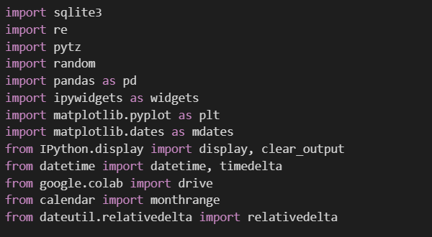 | 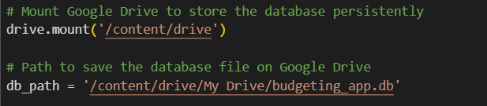
Figure 4.1: Libraries Imported | Figure 4.2: Mount Google Drive

Figure 4.1 shows that the imports in the provided code are essential for building a comprehensive, interactive budgeting application within a Jupyter Notebook or Google Colab environment. SQLite3 is used to create and manage the app's lightweight, file-based database for users, accounts, transactions, budgets, and more. Re supports regular expression operations for validating user inputs like email and password strength. pytz is imported (though not used directly in the visible code) for timezone-aware datetime handling. Random is used to display motivational finance quotes randomly. Pandas, as pd, is used for manipulating and displaying transaction data tables, especially in the dashboard. ipywidgets as widgets enables the app’s interactive UI components such as buttons, forms, and dropdowns. matplotlib.pyplot as plt and matplotlib.dates as mdates generate income vs. expense visualizations and trends over time using charts. The interface can display and clear interface content through functions provided by IPython.Display. The manipulation of date ranges happens most efficiently with the help of the dateutil. The Relative delta library specializes in monthly and yearly duration calculations. The system backend relies on these libraries to run its logic as well as handle user validation and protect data visualization functions, together with dynamic UI features.

Figure 4.2 is the script that first establishes a connection between Google Drive and Colab, and afterward it provides a file destination for SQLite database storage. Notebooks connect with the user's Google Drive folders through the Drive.mount('/content/drive') command, which provides drive folder access at /content/drive. The storage of essential data, like user information as well as budgets and transactions, needs this setup to maintain continuous availability after Colab session termination. The db_path variable receives the complete path to save budgeting_app.db as the SQLite database file inside the My Drive directory of the mounted Google Drive. The setup enables the budgeting application to access and modify the persistent database file through various sessions.

4.2.2 Database Setup
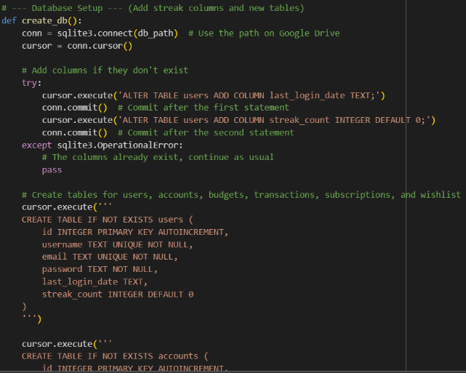 | 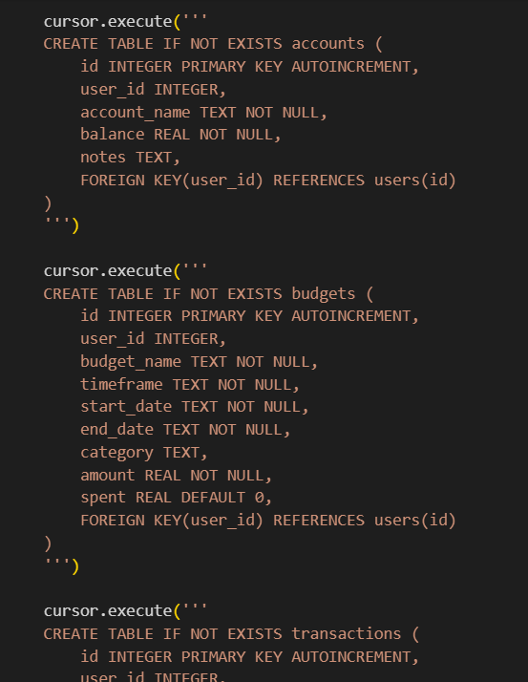
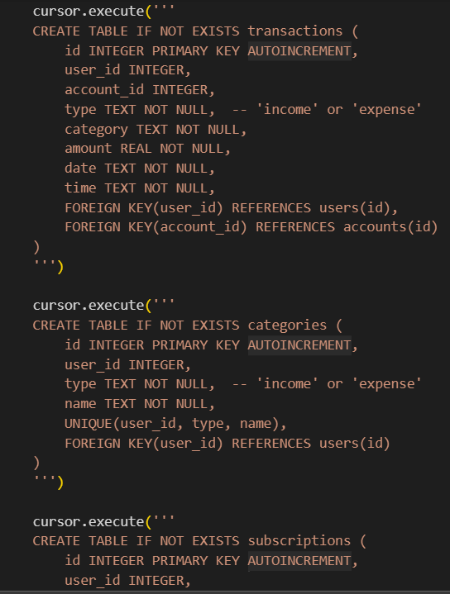 | 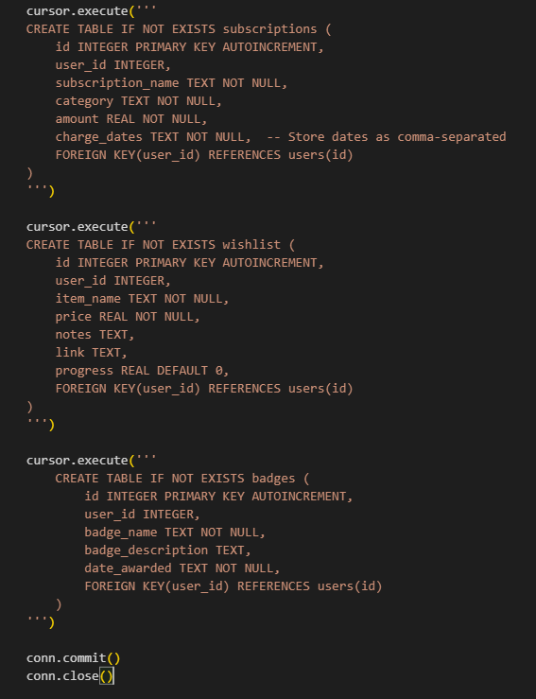
Figure 4.3: Database Setup

The budgeting application requires the create_db() function to establish its database structure according to the following code. Through SQLite database access in the user’s Google Drive, the code establishes a cursor for running SQL commands. The system modifies the user's table with new columns last_login_date and streak_count, but only if they do not yet exist, to manage user login streaks. The SQL queries progressively make critical database tables through specific CREATE TABLE IF NOT EXISTS commands. SuMoney operates through 9 essential tables, which consist of users, accounts, budgets, transactions, categories, and subscriptions, alongside a wishlist and badges to store achievements. The database tables establish personalized, secure data management through their relationship with the users table by utilizing foreign keys. The database completion function submits changes before it closes the connection, which prepares the application with a structured financial tracking system.

4.2.3 Validation & Authentication System
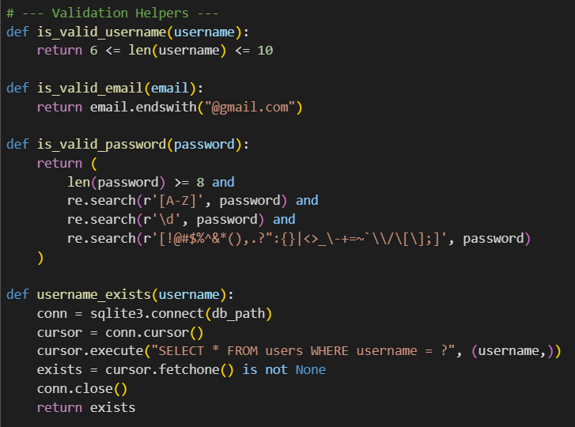 | 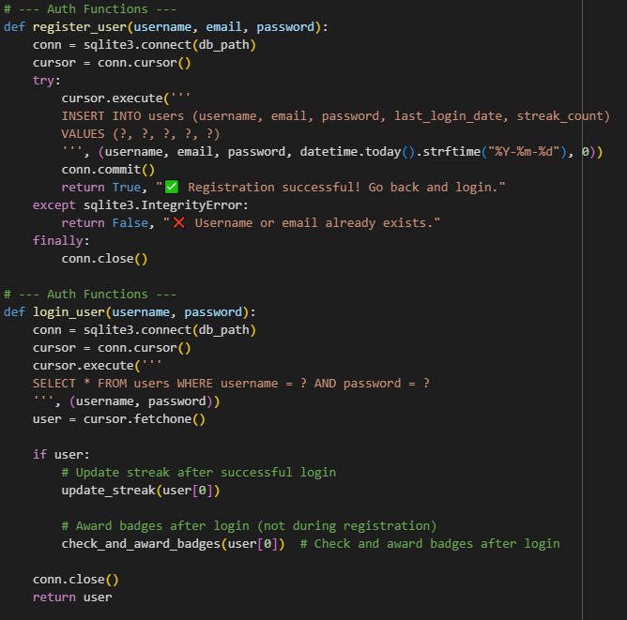
Figure 4.4: Validation System | Figure 4.5: Authentication System

Figure 4.4 represents helper validation functions that are utilized to ensure that user input while registering on the budget system is acceptable. is_valid_username() makes sure that a username is between 6 and 10 characters, promoting uniformity and deterring very short or very long usernames. is_valid_email() makes sure that the domain of the email is "@gmail.com", to ensure only Gmail users can register for simplicity or compatibility purposes. is_valid_password() imposes strong password security of at least 8 characters, an uppercase letter, a digit, and a special character, thereby safeguarding the user accounts against weak-password attacks. The username_exists() function performs a database inquiry to verify if the inputted username appears in the users table to stop users from selecting previously taken usernames. The budgeting app depends on these security functions for maintaining both user authentication security and database integrity.
Figure 4.5 handles user registration and login for the budgeting application. The register_user() function creates new users by storing their username together with Gmail address in addition to a textual or hashed password format and setting the current date as last_login_date alongside a streak_count value of zero, which it inserts into the users table. The registration succeeds if it returns a success notice and produces an error notice when the username or email combination already exists, with a database constraint violation exception handling. Through the login_user() function system verifies login access by searching for a database entry that matches both username and password. Successful authentication results in the streak counter being updated through update_streak() while check_and_award_badges() provides badges to users according to the app's gamification goals. The system protects the app access for valid users by providing streak tracking and badge incentive features.

4.2.5 Streak Logic
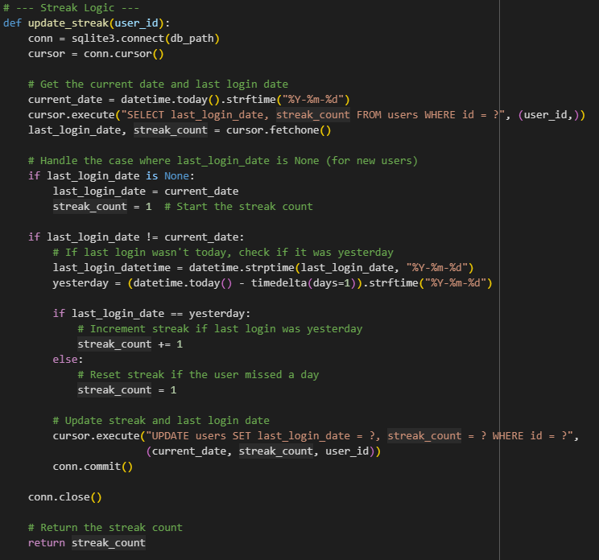
Figure 4.6: Streak Logic

Figure 4.6 is the procedure update_streak(user_id) manages user daily login streaks within the budgeting application by updating the database. The user's streak start value is set to 1 when the current date exceeds their recorded last login day or when the user fails to log in at all. A streak value increases by 1 when the user logs in on the day before. The database receives this updated streak value together with the new recorded login timestamp. The implemented function creates increased user retention through regular usage because it provides rewards for maintaining daily app usage.

4.2.4 Welcome Message & Financial quotes features
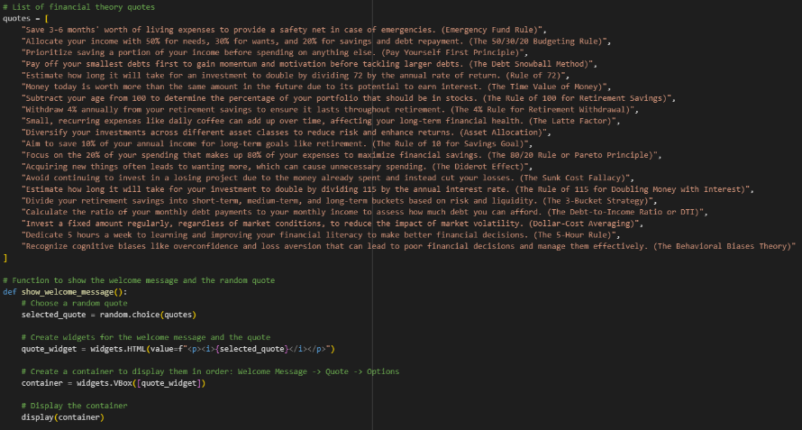
Figure 4.7: Welcoming Message & Financial Quotes

Figure 4.7 represents the interface component of the system raises user interaction and financial education through randomly chosen financial quotations shown to users when they access the budgeting application. The system shows well-known financial guidelines from emergency funds to the asset allocation rule and the 50/30/20 breakdown, together with the rule of 72, as both educational materials and motivational tips. The show_welcome_message() function selects a random piece of financial wisdom using Python’s random.choice() methodology before it creates an ipywidgets HTML widget display within a vertical layout. The system delivers customized dynamic material that simultaneously creates better financial practices by presenting helpful price insights to customers regularly.

4.2.5 UI Components (Main Menu)
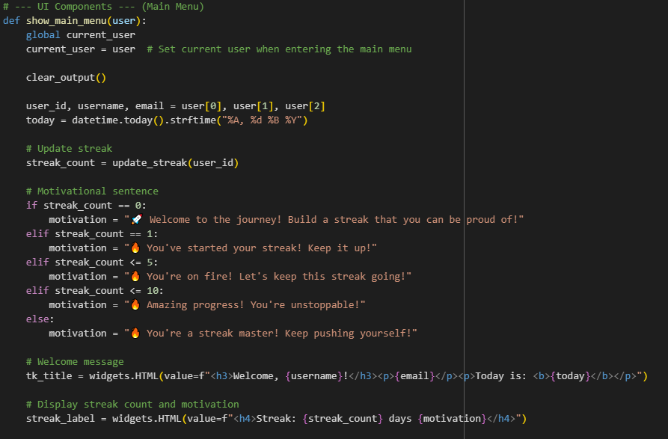 | 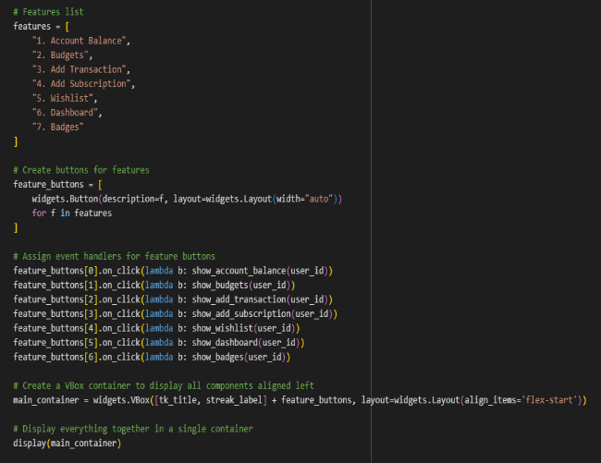
Figure 4.8: UI Components

Figure 4.8 shows the code in this section that develops the principal interactive dashboard for budgeting, which becomes accessible following user authentication. Within the show_main_menu(user) function the system displays a user-specific greeting accompanied by their user name and email address and displays the current date followed by an updated tracking of their login streak and a motivational message tailored to their streak duration such as "🔥 You're on fire! Let's keep this streak going!". A dynamic button creation process follows the core app structural definition stage, which includes Account Balance, Budgets, Add Transaction, Add Subscription, Wishlist, Dashboard, and Badges features. The buttons use event handlers that launch their allocated feature screens after a user clicks on them. The interface presents a clean structure thanks to a vertical box layout (VBox) combined with aligned formatting for all its elements. Through this main menu, the user can navigate seamlessly throughout all essential features of the app.

4.2.6 Authentication Choice, Login, Register Screen
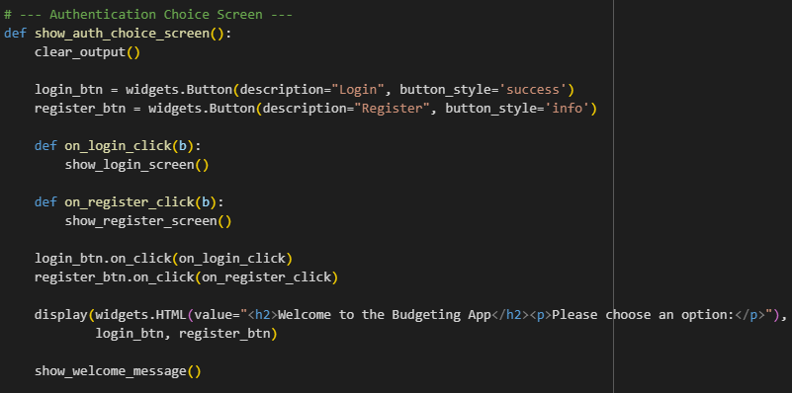 | 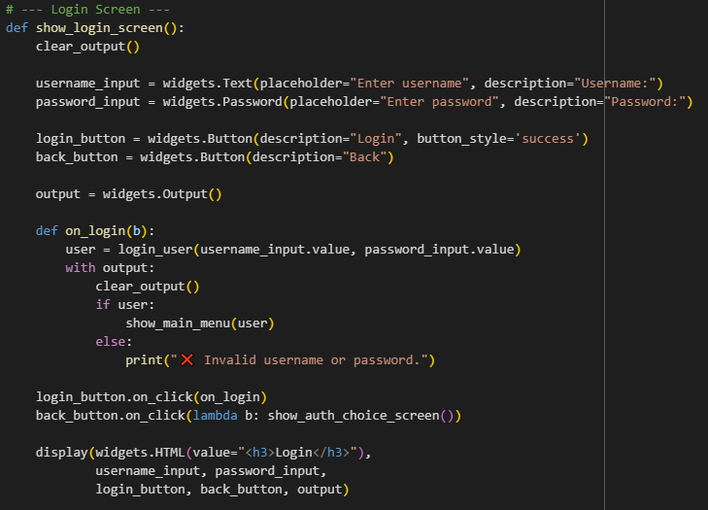
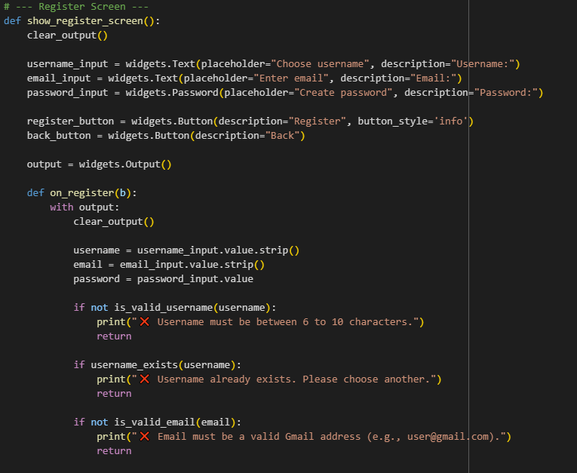 | 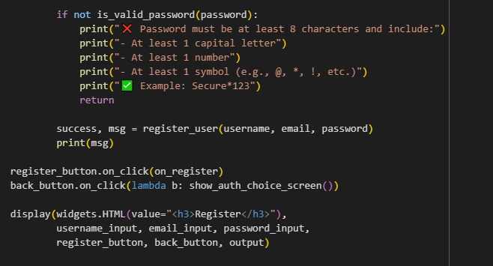
Figure 4.9: Authentication Choice, Login, Register Screen

Figure 4.9 shows user authentication features form an essential part of the system, which includes alternative routes for users to register or log in before accessing budgeting tools. The show_auth_choice_screen() function shows two buttons, namely Login and Register, which are distinguished via design elements, and they lead to functions that populate their dedicated input pages. show_login_screen() shows the username and password input fields through its interface and includes a login button to execute the login_user() function, which verifies entered credentials. The successful login leads users to the main menu, but login failures result in displaying an error message. The show_register_screen() procedure obtains a new username and Gmail address, and a secure password from users while validating their inputs through specific custom rules. The system creates new users through register_user() after successful check completions, while showing a confirmation message to the user. The interface always provides an easy-to-use experience through secure features that control personalized budget access for any user.

4.2.7 View Accounts, Delete Accounts, Add Accounts Functions
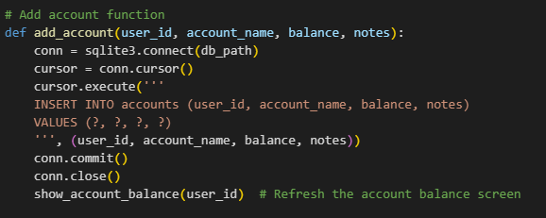 | 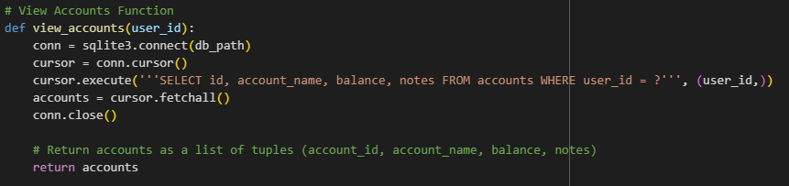
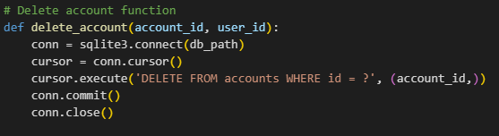
Figure 4.10: View Accounts, Delete Accounts, Add Accounts Functions

Figure 4.10 is the budgeting application that uses these functions for managing financial accounts, where users maintain records regarding their accounts through additions and views as well and deletions. The add_account() function inserts new accounts into the accounts table, which includes name information alongside balance details and notes, user_id association, and updates the account view. The view_accounts() function obtains user-specific accounts as a list of tuples with account details, including account ID, name, balance, and notes, for displaying this data in the interface. Users can perform database management using the delete_account() function, which deletes accounts under selection with a conditional account_id for cleansing records. The application functions enable dynamic user-specific financial account tracking in a way that centralizes the app's personalized money management elements.

4.2.8 Show Budget, View Budget, Deletion of Budget Dropdown
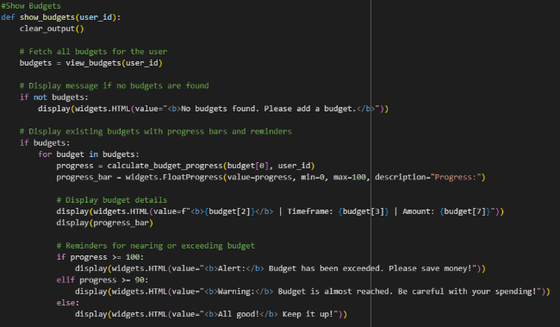 | 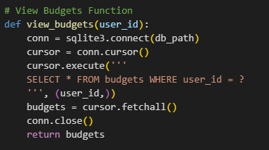
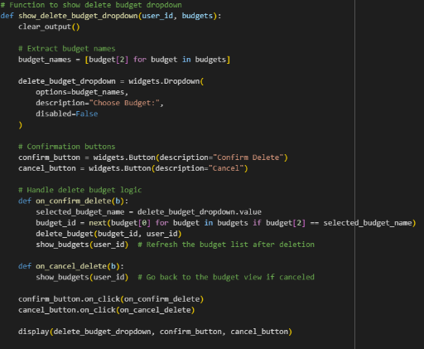
Figure 4.11: Budget, View Budget, Deletion of Budget Dropdown

Figure 4.11 accomplishes this through these functions; the budgeting application enables users to view and delete their budget definitions, thus advancing their control of finances and financial awareness. The view_budgets(user_id) function obtains all budget records linked to a particular user that exist in the database. After obtaining budgets with show_budgets(user_id), the application shows budgets to users as progress bars to track spending while displaying visual warnings for upcoming or exceeded budget limits. The interface alerts users to create a budget when one does not exist at the time. The show_delete_budget_dropdown(user_id, budgets) function presents a user selection interface for budget removal. The interface shows budget names through a dropdown menu, while it contains safety features like confirmation and cancellation buttons, which manage budget deletion. The view refreshes instantly to display the latest budget list when a user deletes any budget. Such features enhance user experience by letting them monitor and maintain their financial plans through an easy-to-use interface.

4.2.9 Show Add Transaction
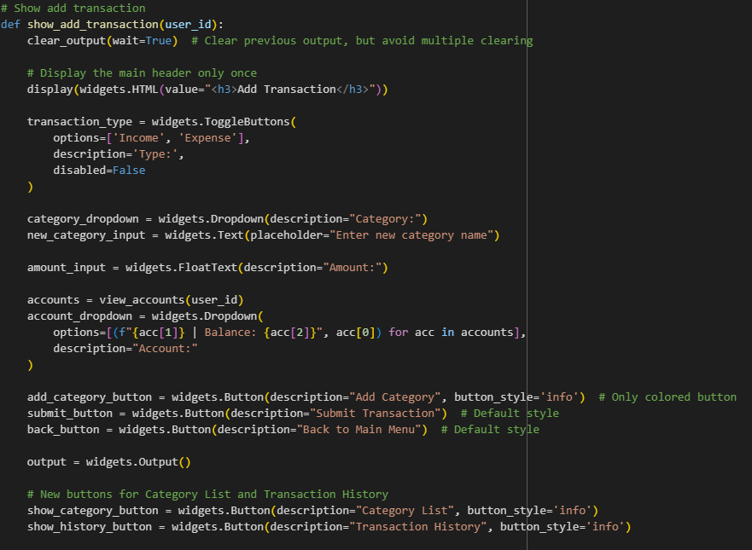 | 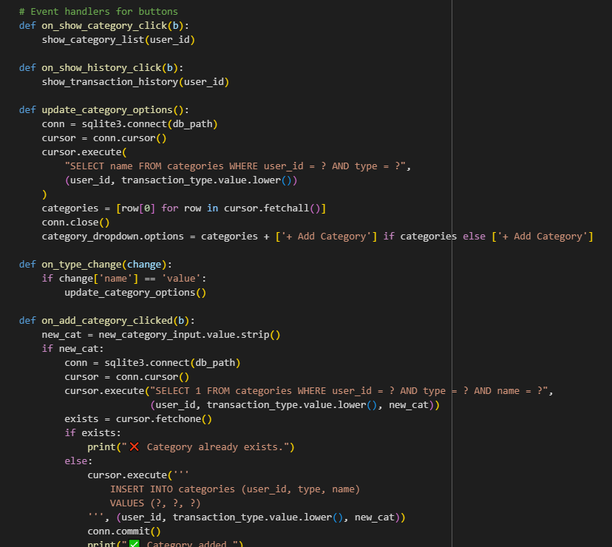
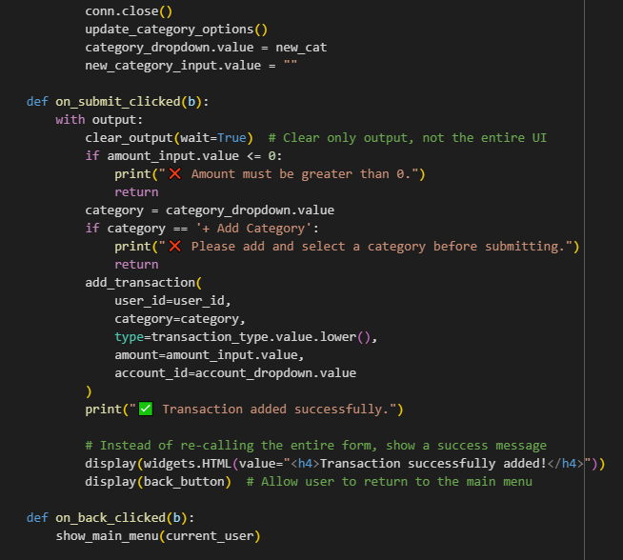 | 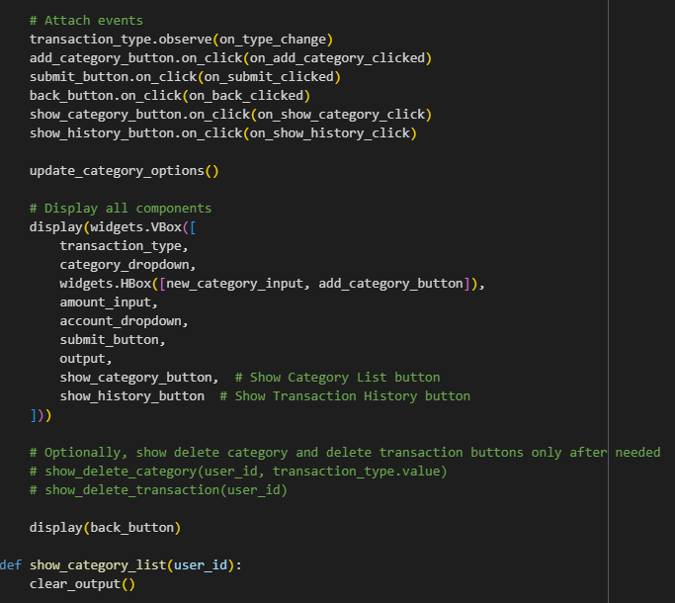
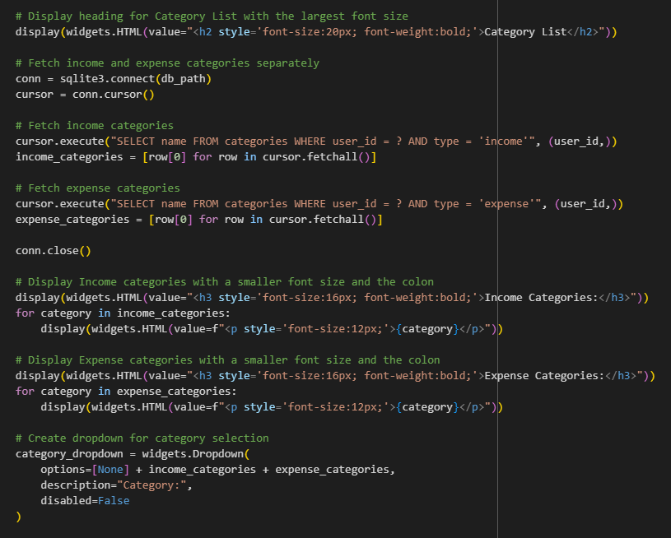 | 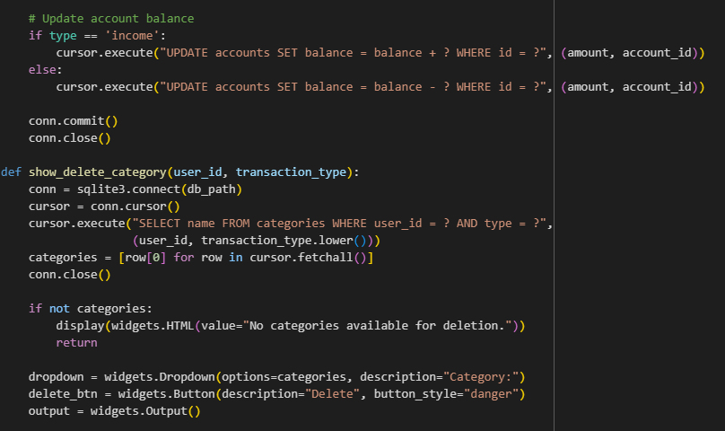
Figure 4.12: Add Transaction Functions/Features

Figure 4.12 allows users access to the “Add Transaction” functionality through this section of the system, which offers an elegant user interface to record both income and expenses. The show_add_transaction(user_id) function first creates a transaction form that allows users to select expense or income types as well as enter amounts while selecting categories and associated accounts. When users choose transaction types, the system automatically loads appropriate categories through update_category_options(). Users can also create new categories by triggering the on_add_category_clicked() functionality. The system stops users from creating duplicate categories that already exist in the database. Through the interface, users can find buttons for accessing the category list or viewing transaction history to improve their experience with navigation and convenience. Float windows ensure the entry of numeric values, while ipywidgets organize all interactive components throughout the interface for a neat presentation.

Upon form completion, the user will activate the on_submit_clicked() function that verifies both positive amounts and selected categories before executing add_transaction() to add the database entry for user ID, category, type, amount, date, time, and account ID. Upon successful submission of the data, the system shows a confirmation message before displaying a back button for returning to the main menu. The show_category_list(user_id) function displays user-related income and expense categories through an easily readable layout, sorted by their type classification. A streamlined financial tracking process exists through this scheme to help users streamline cash flow documentation and monitor their financial operations in a personalized, orderly fashion.

4.2.10 Show Dashboard
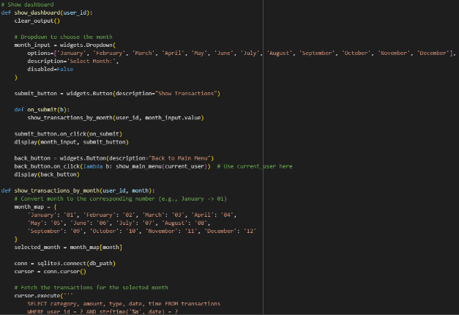 | 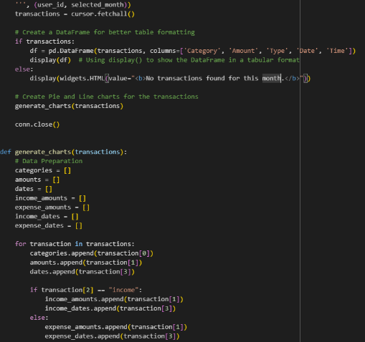
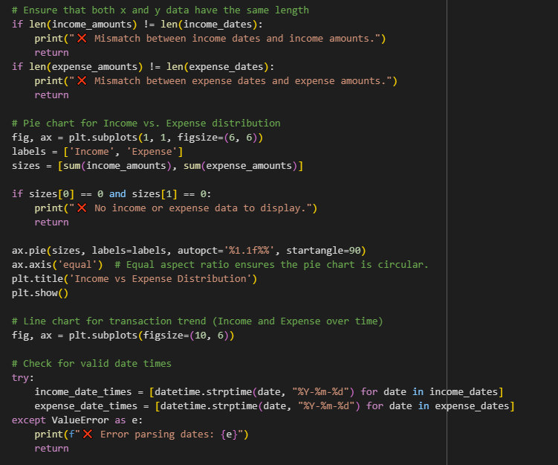 | 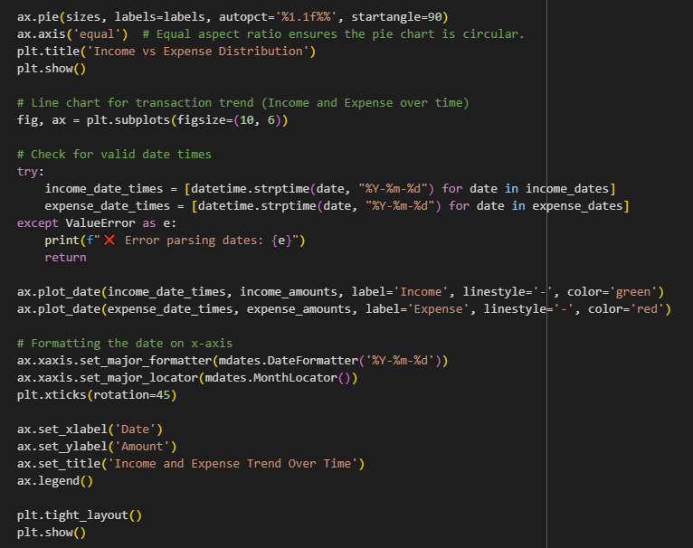
Figure 4.13: Dashboard

Figure 4.13 shows that the built-in dashboard in this budgeting application allows users to see their monthly financial transaction details. The show_dashboard(user_id) function begins with a display of a month selection dropdown menu for users. Users can access show_transactions_by_month() after selecting a month and pressing the "Show Transactions" button, following their selection of button. The function collects all transactions for that month based on database queries. The program generates a clean tabular display based on Pandas DataFrames that shows transaction details with category information, together with amount, expenses, or income, date, and time. In cases where users have no transactions for the selected month, the program shows a message to inform them instead of empty data fields. Users can access the dashboard hub directly from the "Back to Main Menu" button.
The generate_charts() function serves as an enhancement to provide visual representations of the acquired transaction data. The pie chart function generates visual data to demonstrate income and expenses ratios, which shows users their financial standing for the month. The generated line chart shows the monthly evolution of income and expenses through a combination of x-axis dates and y-axis amounts. Users can easily see the financial changes that occurred during each of the month's days through this graphical display. The function integrates two safety measures by validating data accuracy while preventing graphical errors related to data value misalignments or formatting problems. Better user experience occurs through the dashboard feature when it converts complex financial data into visual information that leads to superior budget decisions.

4.2.11 Show Badges
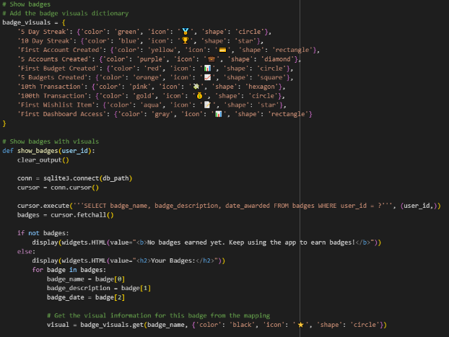 | 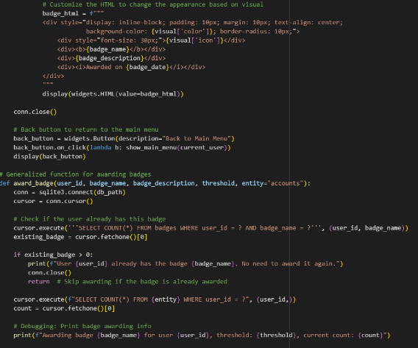
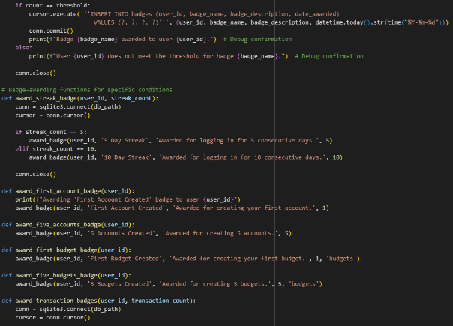 | 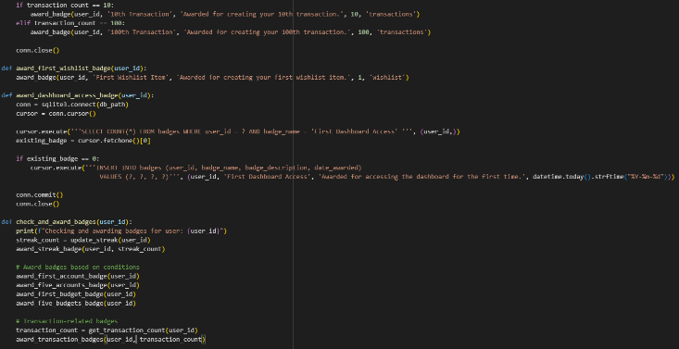
Figure 4.14: Show Badges

Figure 4.14 points out that through badges, users can earn as part of the system, and they can achieve consistent access, while the rewards system acknowledges their financial achievements. A user_id value sent to the show_badges(user_id) function allows the system to obtain all badges from the database for active display. The badge_visuals dictionary applies distinctive visual styles that use blend badge color with symbolic icons, along with shapes, to present badges in an engaging design. As part of this system, users obtain visual access to badge names and descriptions alongside their award date through an attractive ipywidgets HTML design. The system presents motivational content to unawarded users because their usage track lacks badge achievements. The interface enables users to experience increased personal rewards through its design, which improves their achievement satisfaction.
The system provides award_badge() as a generalized function that distributes badges by taking a user ID together with badge name, description, threshold count, and selectable data entity (such as accounts, budgets, or transactions). The function verifies badge possession by the user and examines their item quantity against the specified threshold value. The system creates a new badge record with the current date in the database under this condition when the specified requirements are satisfied and the badge has never been awarded before. Through the modular structure, badges can be awarded to users only once per milestone, and the system maintains flexibility for future badge conditions.
The process of assigning badges is simplified through specific badge-triggering functions that define the conditions for badge activation. The award_streak_badge() function identifies consecutive login durations of 5 days and 10 days, and award_first_account_badge() and award_five_accounts_badge(), respectively, reward users for their first and fifth account creations. The system provides badges to users who create budgets (award_first_budget_badge, award_five_budgets_badge) and reach transaction milestones (award_transaction_badges), and log first usage of the dashboard. The functions direct the generalized award_badge() procedure with proper threshold values and entity references, which maintains a flexible system for managing numerous accomplishments.
The check_and_award_badges(user_id) function operates as a comprehensive mechanism to verify badges for users. The system activates as a result of authentication and determines potential badges based on the latest user records. The function triggers every associated badge-triggering function sequence before making necessary database updates. Through automated distribution, the system awards badges to users without their manual intervention, so they receive instant feedback for activities such as regular application use and budget tracking. The badge system provides gamification to the app by using goal achievements to drive users toward continuous advancement in their financial management habits.

4.2.12 App Runner & Database Management
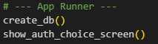
Figure 4.15: App Runner

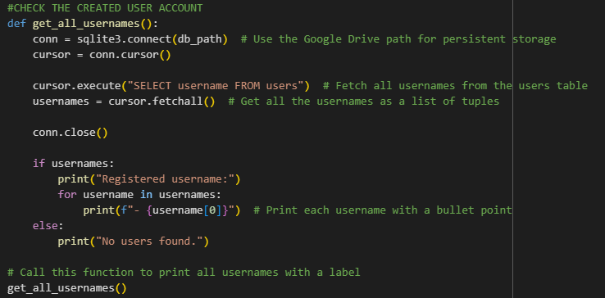 | 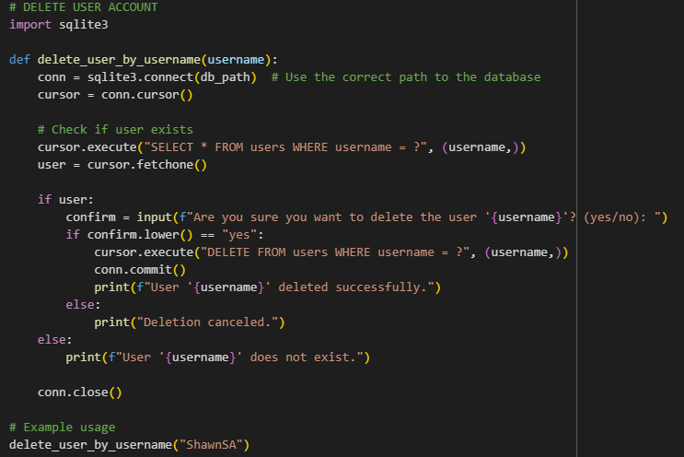
Figure 4.16: Database Management

Figure 4.15 is the last section of the system that acts as the gateway to activate budgeting application execution. The create_db() function executes first to generate database tables, including users, accounts, budgets, transactions, badges, and more, unless these tables already exist. It verifies that important database columns like last_login_date and streak_count are established. The program prepares the database for storing user information across sessions. Immediately afterwards, the show_auth_choice_screen() function begins execution, which displays the user interface where users can select between logging in or registering. The setup sequence includes two steps, which make sure both backend initialization and frontend user readiness are completed before activating the entire budgeting system for use.
Figure 4.16 shows that the system implements get_all_usernames() as a supporting functionality that obtains and shows all usernames stored in the SQLite database of the system. The database located on Google Drive serves persistence through this function, which first connects before executing the query to retrieve all usernames from the users table, then closes the connection. The function shows existing user names with bullet points one by one, unless there are no user accounts present. As a supplementary feature, the function enables administrators or testers to inspect user account storage within the system through its dedicated interface for debugging needs.
The delete_user_by_username(username) function provides manual user account deletion capability to administrators and developers through database access by username entry. The function aims to verify the existence of a username within the users table of the SQLite database after it establishes its connection. The process proceeds with user deletion after it finds a match in the system. But it first displays a confirmation request through console dialogue input. The function deletes user data after confirming with "yes," and it commits this change, but stops the operation upon any other confirmation. The program shows an appropriate notification when the requested user is not present in the system database. As an important back-end management tool, this function enables developers to handle user data for debugging purposes and maintenance needs, or development phases.

4.3 Implementation (User Interface)
The following section explains the design approach for the improved budgeting app while describing its deployment and user interface components with particular attention to Gen Z users. The application includes features for user authentication while utilizing streak logic combined with account and budget management features and transaction tracking, and wishlist functionalities. Additionally, this section also explains the use of interactive elements such as widgets to create a dynamic user experience, along with gamification features like badges and progress tracking. Additionally, it highlights the visualizations and insights provided through the dashboard, aimed at helping users manage their finances more effectively.

4.3.1 Welcome Page
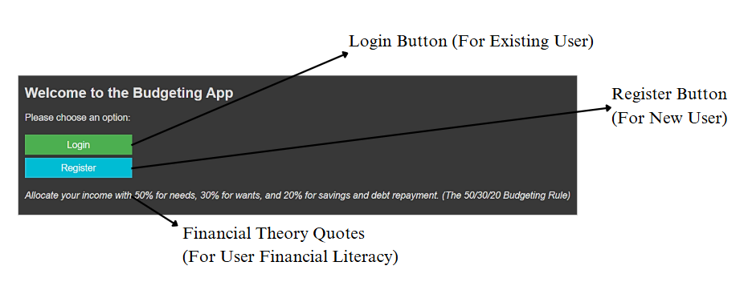
Figure 4.16: Welcome Page

The budgeting application initializes its operations through the Welcome Page, which offers an easy-to-use entry system for all users. The application will present users with separate buttons for login access for returning customers and registration access for new users upon the initial launch. The Login button directs returning users to the login screen, where they can input their credentials to access their account. Conversely, the Register button takes new users to the registration page, allowing them to create a new account. A random quote of financial theory is displayed below these buttons. The app presents short, meaningful financial wisdom to Gen Z users each time they launch the application to help them develop financial expertise through direct yet captivating messages. The quotes change with each session, ensuring that users are introduced to different financial principles in a digestible, user-friendly manner. The design achieves a great user experience by uniting educational features with navigation functionality in a simple and attractive user interface.

4.3.2 Registration Page
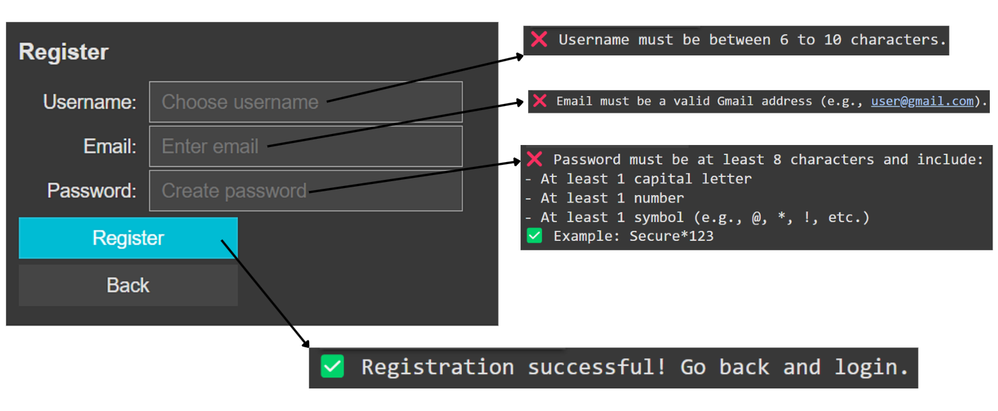
Figure 4.17: Registration Page

The Registration Page enables new users to create accounts after clicking the "Register" button on the Welcome Page. To ensure proper account creation, the user must input a unique username, a valid email address, and a secure password. Each field has specific validation rules: the username must be between 6 and 10 characters; the email must end with "@gmail.com"; and the password must be at least 8 characters long, containing at least one capital letter, one number, and one special symbol (e.g., @, *, !). The application verifies username uniqueness, so users must select different names when their name is already registered in the system.
After completing account registration, the system will send you a confirmation message about your new account. The validation procedure results in personalized, accurate, secure user data, which facilitates secure registration experiences for users.

4.3.3 Login Page
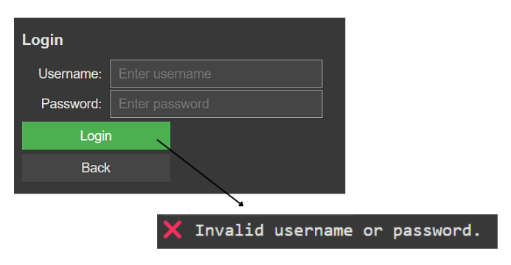
Figure 4.18: Login Page
The Login Page emerges after users select the "Login" button located on the Welcome Page. The main menu becomes accessible only after users provide their valid username and password combination. The system accepts valid credentials to offer users access to the main menu after successful login. The system shows "Invalid username or password" when users provide incorrect login credentials, as shown in the figure above. The system provides users with notifications for unsuccessful login attempts to help them resolve the authentication problem.

4.3.4 Main Menu Page
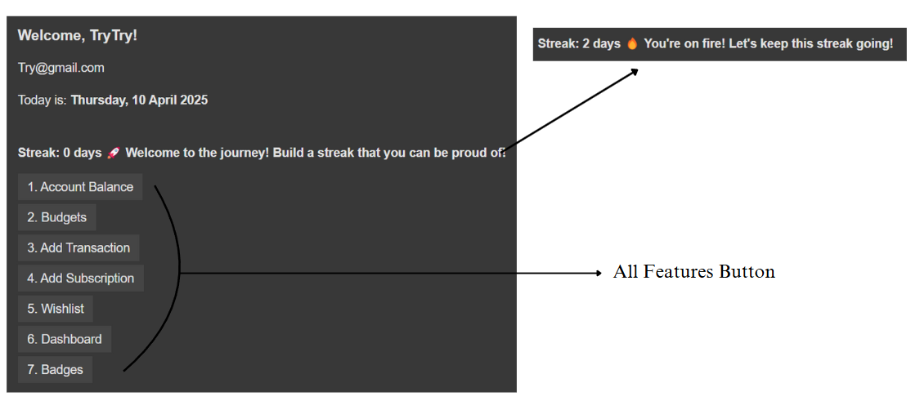
Figure 4.19: Main Menu Page

The system presents the Main Menu Page following successful login. When users first visit the page, they encounter their username followed by email and date information displayed on top of the screen. A distinctive element of the app features the streak counter, which presents to users the number of times they have used the app in a row. The system includes a particular design element for Gen Z users, which displays their engagement progress in a visual format. Alongside the streak count, a dynamic motivational message is shown, which updates based on the user's streak length.
Users can locate seven feature buttons located beneath the streak counter. The seven buttons located at the bottom allow users to access essential app features such as seeing their account balances and budgets, making transactions and subscriptions, tracking wishlist items, viewing their dashboard, and earning badges. The app interface contains seven buttons that lead users to various parts of the application to provide an extensive interactive experience.

4.3.5 Account Balance Feature
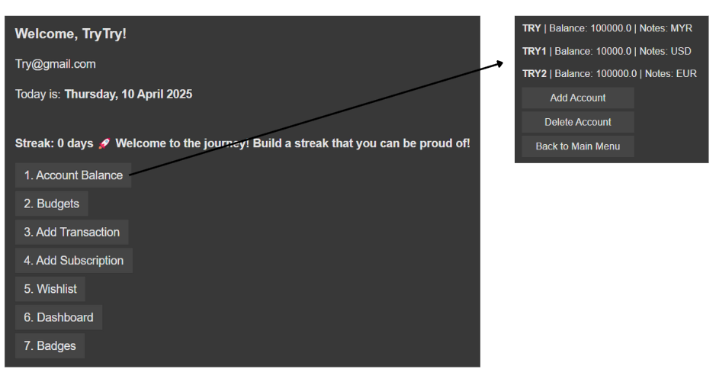
Figure 4.20: Account Balance Feature

The Account Balance Feature becomes available after users click the "Account Balance" button located in the Main Menu. On this page, the user’s existing accounts, such as bank accounts, e-money accounts, etc, are displayed along with their details, including the account balance and associated notes. Users have access to two crucial buttons that allow them to create new accounts and delete existing ones. Users can create new accounts through the "Add Account" button, while the "Delete Account" button allows them to remove existing accounts. The application provides users with a simple tool to handle their financial accounts directly from within the program interface.

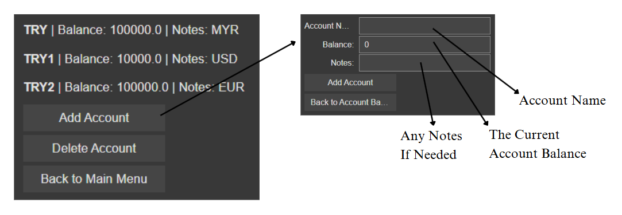
Figure 4.21: Add Account Feature

Users can easily add new financial accounts to the system using the "Add Account" feature in the application. Users must enter the account name together with the current balance and optional additional notes after pressing "Add Account." Users can save new account system details by clicking the "Add Account" button after filling in all necessary information. Users can easily understand the interface because it separates the account name field from the balance field and note field functions.

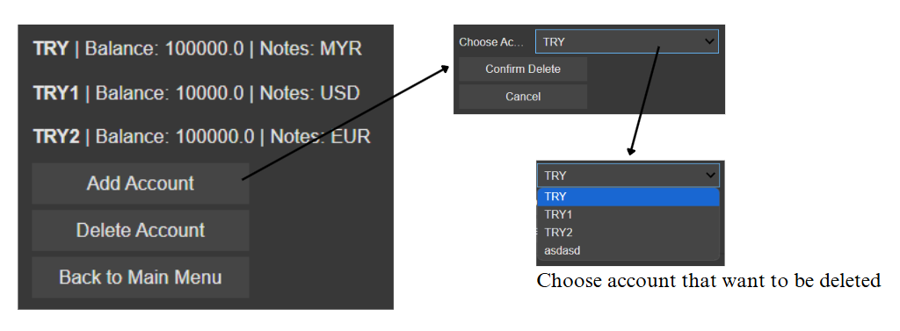
Figure 4.22: Delete Account Feature

The "Delete Account" feature is displayed after the user clicks the "Delete Account" button. The user must choose their desired account for deletion from a displayed drop-down list containing all their available accounts. The user can use the "Delete Account" button to make their chosen account disappear permanently after selecting it from the list. The system allows users to handle and remove extra accounts through this functionality.

4.3.6 Budgets Feature
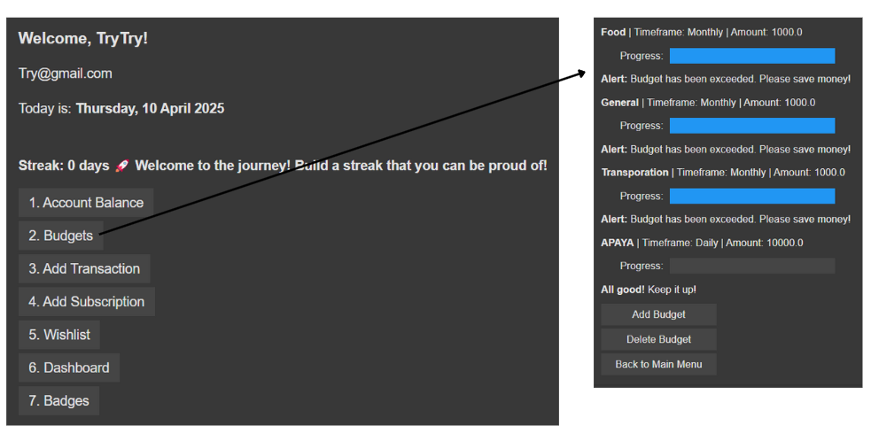
Figure 4.23: Budgets Feature

The user can access the Budgets Feature by selecting Budgets from the Main Menu. The page shows both existing budgets and their specifications, which include budget names and timeframes, and total budget values. The displayed progress bars on each budget show users their spending progress against their budget amounts. The system warns users through an alert when their budgets approach the specified limits or surpass them. The user interface allows the user to handle budgets through the "Add Budget" button for new budget creation and the "Delete Budget" button for budget removal. The platform gives users an easy method to monitor their spending towards their predetermined financial objectives.

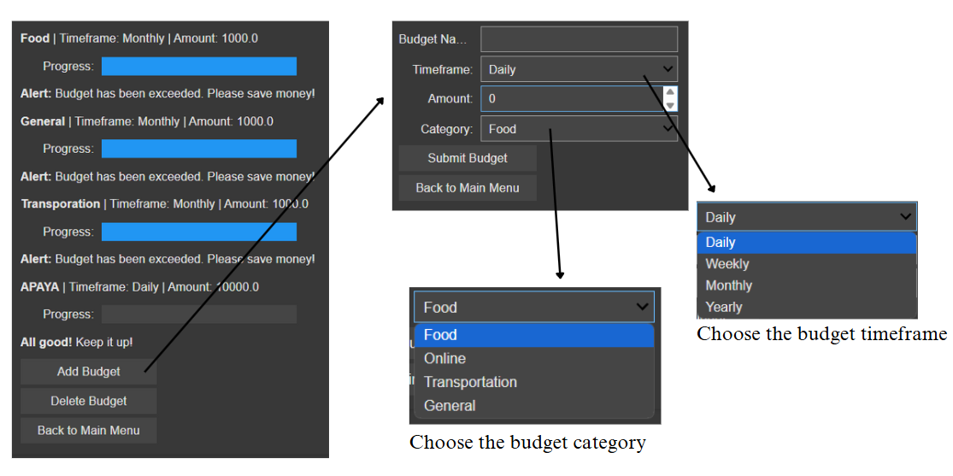
Figure 4.24: Add Budgets Feature

The application displays the "Add Budget" feature when users select the "Add Budget" button. Users can establish new budgets by filling in mandatory information and pressing the "Submit Budget" button in this view. The user needs to choose between the timeframe and category before budget creation. The choice of timeframe sets how long the budget lasts until it reaches zero, and users can select daily, weekly, monthly, or yearly durations. Budget tracking focuses on a specific type of expenses based on the category selection. The selection of "Food" as a category will force the budget to track only food costs. The "General" category separates itself from other options because it monitors expenses from all types without category restrictions, thus providing broad spending oversight.

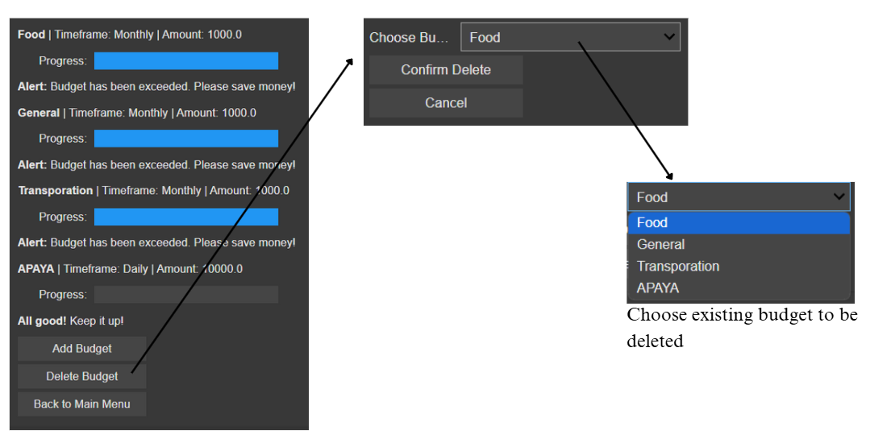
Figure 4.25: Delete Budgets Feature

Users can view the "Delete Budget" feature after clicking the "Delete Budget" button. The user interface operates in the same manner as the "Delete Account" function, where the drop-down menu contains the existing budgets from which users must choose one to delete. The user will finalize the budget deletion process by clicking the "Confirm Delete" button after selecting the budget. The selected budget becomes permanently removed after the user clicks Confirm Delete.

4.3.7 Add Transaction Feature
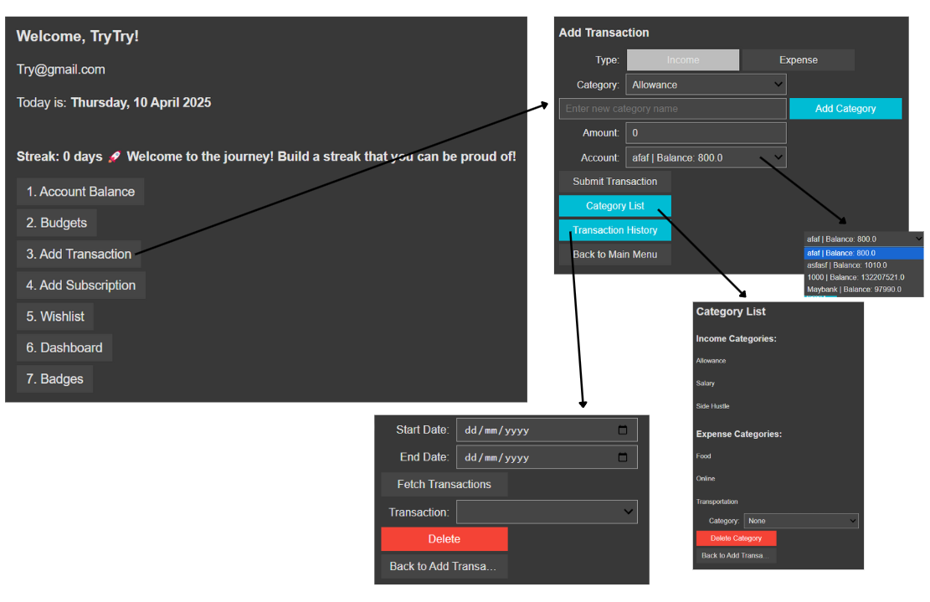
Figure 4.26: Add Transaction Feature

The "Add Transaction" feature allows users to add both income and expense transactions, enabling them to manage their finances effectively. Users must choose between income and expense transactions before starting their new transaction. Users can increase their account balance through income transactions, while expenses deduct funds from the selected account. The user must select a transaction category before entering the transaction amount and choosing the account that will support the transaction.
The system gives users the capability to handle transaction categories through this functionality. The user interface allows new category creation by entering a name, followed by using the "Add Category" button for submission. Through the "Category List" button, users can access all their current categories for viewing and deleting those categories they no longer require.
Users can also view their past transactions by selecting the "Transaction History" button on the screen. A list containing filtered transactions will appear according to the entered date parameters. Users can delete mistaken transactions through the program by selecting the "Delete" button, which functions similarly to other system buttons.
Users need to understand that the "Add Transaction" feature communicates with both budgeting and account balance functions within the system. Transactions modify account balances alongside budget limits so users can maintain a full understanding of their financial position.

4.3.8 Add Subscription Feature
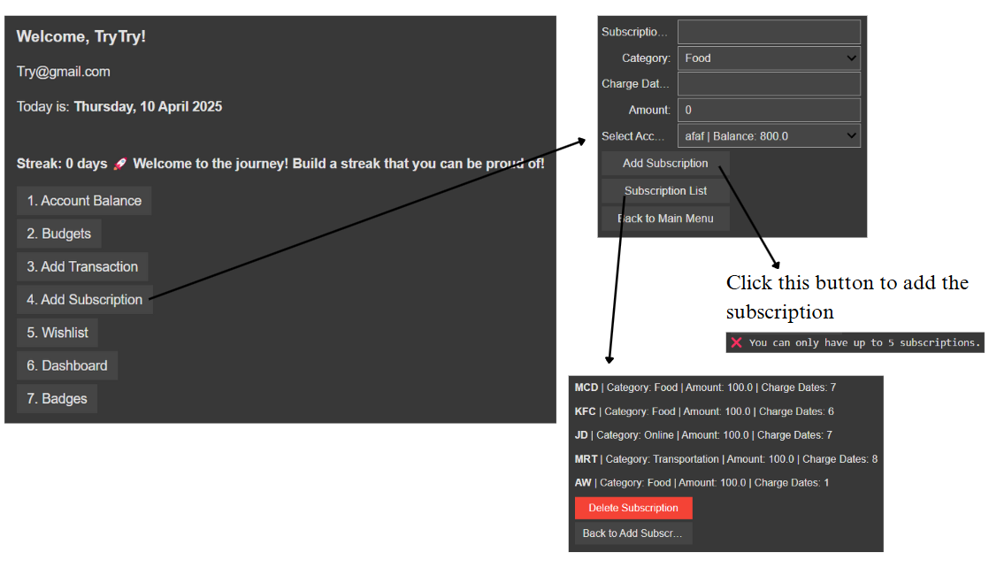
Figure 4.27: Add Subscription Feature

The "Add Subscription" function allows users to handle their repeating expenses exactly like "Add Transaction," but it has special functionality for subscription management. Users should open the feature to find input sections where they can fill subscription information, including subscription name and category and payment dates and amount, and deduction account. Users must complete all necessary subscription fields before using the "Add Subscription" button to create their new entry.

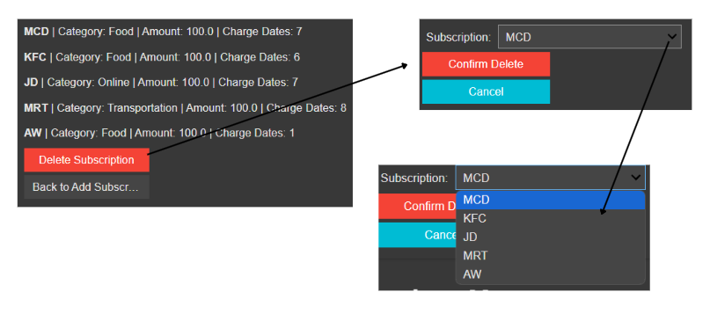
Figure 4.28: Delete Subscription Feature

Each user has a restriction of five active subscriptions within the app framework. The application displays a warning to users who have five active subscriptions when they try to add another one. The feature comes with a "Subscription List" button that shows users all their present subscriptions along with their associated details. Users can maintain a subscription record organization and update it by deleting any subscription through the "Delete Subscription" option located in this list.

4.3.9 Wishlist Feature
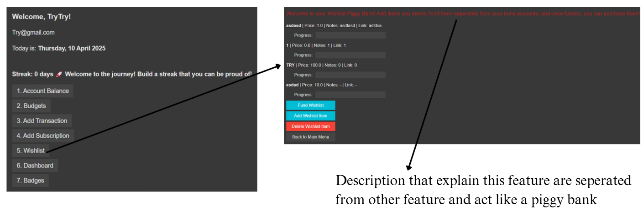
Figure 4.29: Wishlist Feature

The "Wishlist" feature provides users with a dedicated space to manage and fund their desired items, functioning independently from other financial features and acting as a separate "piggy bank." Users find the "Wishlist" option in the Main Menu, which provides information about its operation as an independent feature that tracks items separately from main financial activities. Users can find their current wishlist items beneath the description, with information showing item costs and funding progress, and extra notes and links. The interface shows funding progress through progress bars that appear next to every listed item.
Users can access three action buttons in this feature for wishlist management: the "Fund Wishlist" leads to funding select wishlist items thus advancing purchase objectives and the "Add Wishlist Item" assists in creating new wishlist entries enabling users to define names and prices and add notes and the "Delete Wishlist Item" provides a method to remove wishlist items. The system provides a structured system for users to save money toward specific future buys, yet it maintains separate storage from their standard financial records.

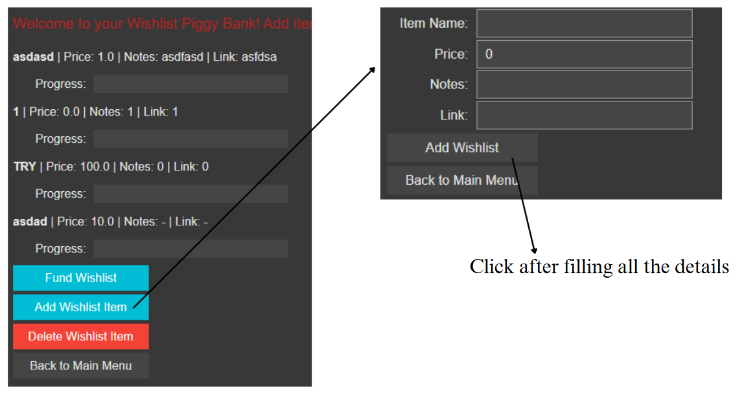
Figure 4.30: Add Wishlist Feature

The user reaches a new screen by clicking "Add Wishlist" to complete the new wishlist item details. The user should input the item name, followed by price details and optional notes, before linking to product information. The user can proceed with the addition by selecting the "Add Wishlist" button after finishing all required item fields.
Users within this application maintain only five wishlist items. The "Add Wishlist" button disables automatically when users exceed their maximum limit of five wishlist items, while a message pops up on top to notify them about reaching their limit. A maximum of five wishlist items becomes the sole limit for user management through this system.

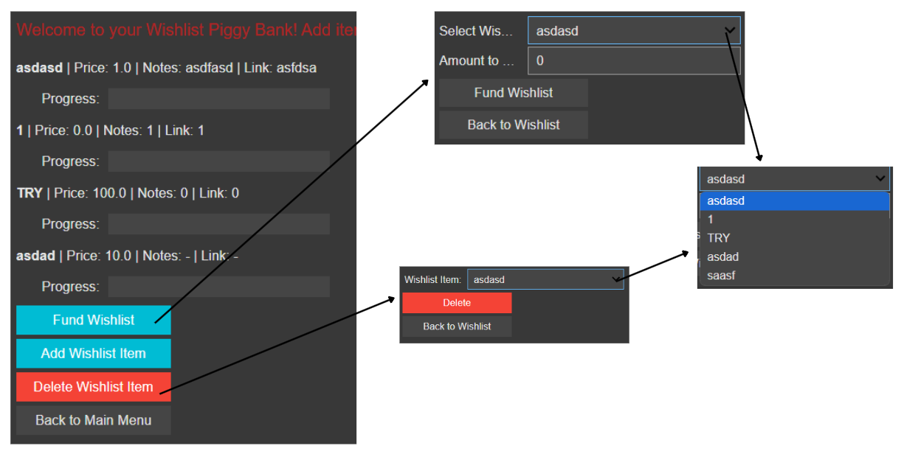
Figure 4.31: Fund and Delete Wishlist Feature

Users can initiate funding their wishlist items by pressing the "Fund Wishlist" button on each specific item. Users must navigate to a new screen through this button selection in order to choose the specific wishlist item they plan to donate. The user must choose their selected item before specifying their monetary contribution amount. Users can progressively add funds to their wishlist items one by one until they achieve their funding target.
Similarly, if a user wants to delete an existing wishlist item, they can do so by clicking the "Delete Wishlist Item" button. Upon choosing this option, the user will see a list of their saved wishlist items appear in the dropdown menu. To complete the deletion, users need to select the desired item from the list and perform a confirmation step. The flexible management of user wishlists becomes possible through this feature because users can remove unwanted items and fund desired ones in a step-by-step fashion.

4.3.10 Dashboard Feature
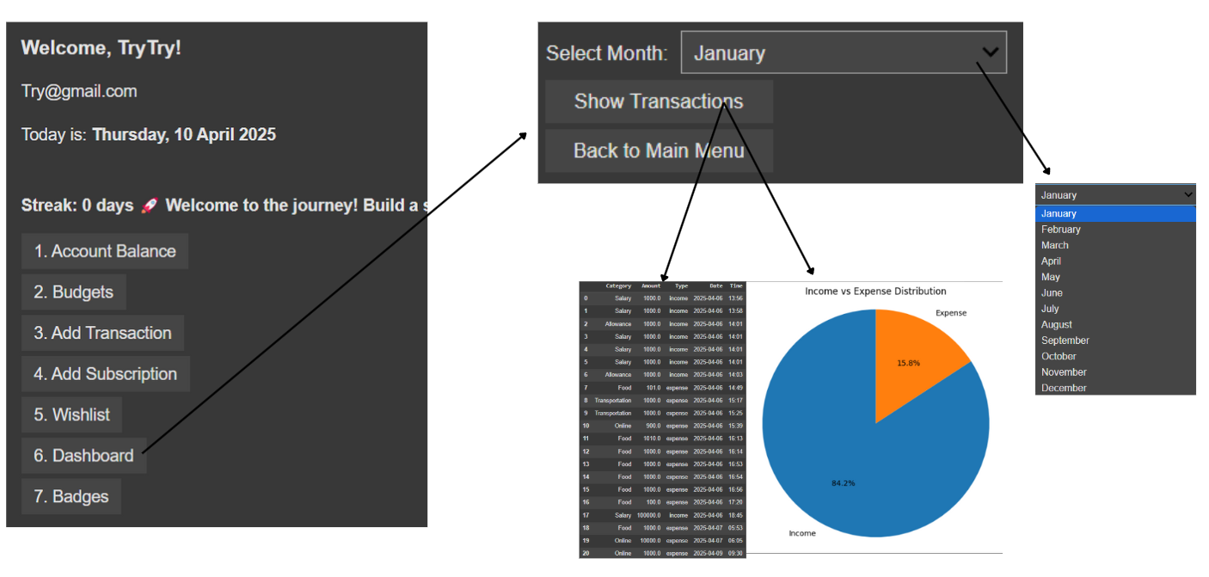
Figure 4.32: Dashboard Feature

The Dashboard feature delivers financial performance and activity view through transaction tracking, which operates within specified periods. The dashboard interface requires users to choose a month from an available selection of options. The user can show transactions for a selected month by clicking the "Show Transactions" button after they have chosen their month. A tabular display shows financial transactions that include category, amount, type (income or expense), date, and time information to facilitate user financial analysis. The application uses pie charts and line graphs as visual tools to show the income and expense percentages and display time-based transaction patterns, respectively. Users can understand financial ratios through pie charts while tracking monthly progress by examining line charts on the system. Users can better plan their finances by understanding their spending patterns because of this feature's visual presentation.

4.3.11 Badges Feature
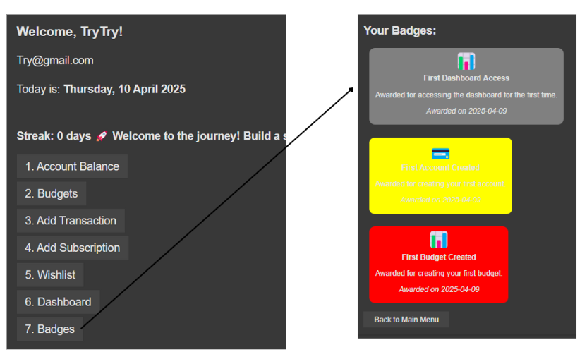
Figure 4.33: Badges Feature

Through the Badges feature, the app turns into a game that rewards users with virtual achievements when they accomplish their financial goals or achieve specific usage milestones. Within the "Badges" section, users find accumulated badges that display their descriptions and dates of receipt. Different achievement badges display through unique visual elements, such as the green "5 Day Streak" badge with a green icon, together with blue "First Account Created" and red "First Budget Created" badges. Users receive badges that reflect their different actions, including account creation and transaction completion, and consecutive login maintenance. Users find achievement more enjoyable through the structured UI, which displays badges in an easy-to-read format, thus encouraging continued use of the application. The system also automatically gives out rewards for reaching specified achievements. The system uses this feature to boost user engagement while simultaneously enhancing overall user experience through the delivery of progress-based achievements.
4.4 System Diagrams
System design is a step of SDLC that aims to meet user demands and give stakeholders visual representations of the system's operation (Narulita et al., 2024). Unified Modeling Language (UML) diagrams are commonly used to describe and document systems before deployment. For PFM development, UML diagrams will include use case, activity, and sequence diagrams. Use cases describe how system stakeholders interact with the system, while activity diagrams design processes based on existing use cases (Hasanah & Untari, 2021). Sequence diagrams visualize related objects within a use case (Sinambela et al., 2024).

4.4.1 Use Case Diagram
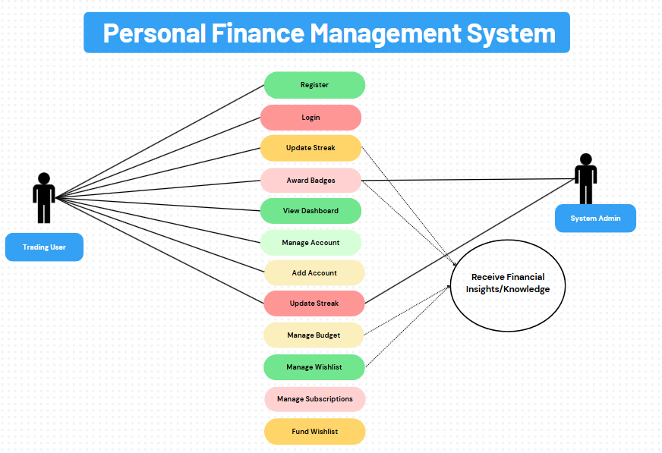
Figure 4.34: Use Case Diagram

The use of use case diagrams provides enhanced system design communication by illustrating actors (stakeholders) and use cases and their connected elements (Hasanah & Untari, 2021). The proposed system use case diagram reveals how “Trading User” functions as the main end-user to utilize the Personal Finance Management System for effective monitoring and management of personal financial activities. Before using the system, users must register their an account to obtain access.
Users who register for the system gain automated login tracking that develops their commitment and prompts continuous system use. When users log in, they can handle their accounts through the feature for adding different types of accounts, like cash, bank, and e-wallets. User budgets are managed through a system that enables the assignment of budget amounts into categories while also defining spending restrictions. Users can add wishlist items that symbolize financial targets and follow funding development together with goal achievement progress. Users can manage subscriptions through the system platform to keep track of regular costs. Through its badge award system, the platform gives users incentives by honoring them with awards when they reach set benchmarks, such as multiple transactions or persistent logins. The system provides dashboard views that present users with visual elements revealing financial trends about their behavior.
The entire process integrates into the system's capability to deliver personalized financial insights, which help users make enhanced financial choices. The “System Admin” functions as a secondary actor who manages system backend maintenance alongside accurate financial insights delivery and badge administration, alongside user activity tracking to protect system integrity. The Personal Finance Management System includes all user experiences and platform elements to deliver an integrated system for financial planning and monitoring with constant enhancement capacity.

4.4.2 Activity Diagram
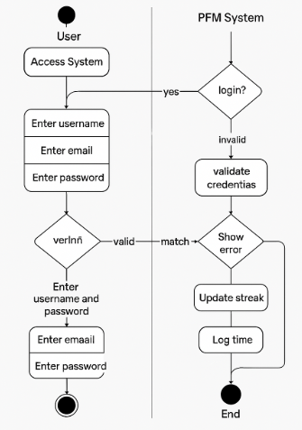
Figure 4.35: Login & Signup Activity Diagram

Our proposed Personal Finance Management (PFM) system utilizes an activity diagram Figure 4.35 to represent its login and signup functionality. The application starts by asking users to perform either a login or a signup procedure. The signup sequence for new users demands both a valid username choice between 6 and 10 characters and a Gmail account with a complex password adhering to specified format rules. System validation occurs on the client side prior to submission of details to the system. The system detects duplicate entries between usernames and emails automatically. According to the established login requirements, users who are reusing the system must provide their previously set username together with their password. The system updates the login streak upon successful authentication by validating the credentials. It accomplishes this by comparing current dates against previous login dates. Users see motivational content relating to their streak number after successful logins, where they are sent to the main menu. The system will display an error prompt when users provide invalid login information, but still permit another attempt.
The system performs automatic badge evaluations immediately after login through user activity tracking of login streaks, together with transaction milestones and account or budget creations, and perspective wishlist maintenance. Without any manual intervention, these rewards get assigned. The system directs users to the home interface, which displays both the account overview along main features. The systematic login process maintains both user protection and system dependability, along with motivation levels for users.
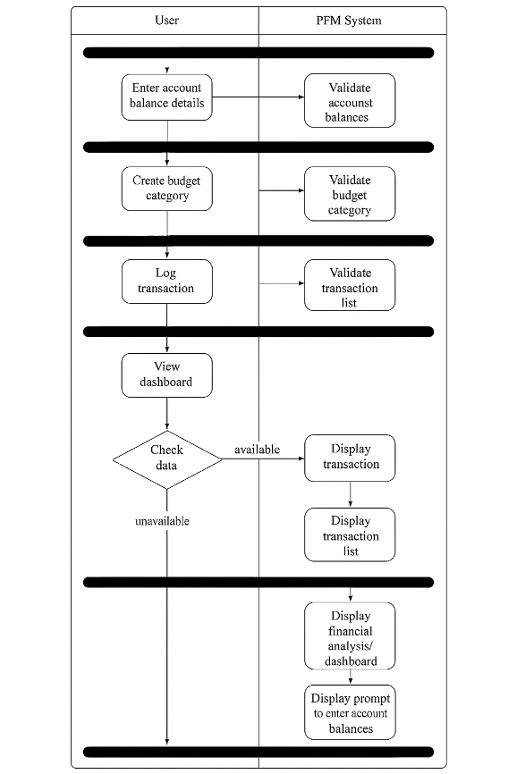
Figure 4.37: Account Balance, Budget Category, Transaction, and Dashboard Activity Diagram

The system follows the sequence of Figure 4.37, which displays essential financial management operations for user interaction starting from account balance input, then budget classification, and afterward transaction recording along with dashboard information presentation. The activity diagram demonstrates how users perform sequential combined with parallel activities inside the system. Users must start by entering their balance information pertaining to savings and checking accounts, alongside e-wallets, after completing account access. The system uses real-time checks on new data to confirm both accurate and original records. Users can establish custom budget categories for typical expenses after validation steps, and the system also verifies these categories. Users must record their financial transactions, which they assign to their created budget categories. A validation process ensures that all data records include accurate amounts, together with related information. Users can view their financial dashboard after adding inputs, where the dashboard appears dynamically from the provided data. The system will first verify if there is enough available data before showing the dashboard to users. Users will see financial summaries and personalized insights through the dashboard, but they must finish initial data entry when the required information is not provided. Together, these integrated procedures maintain data consistency by helping users build financial awareness that enables effective management of personal finances inside our system.

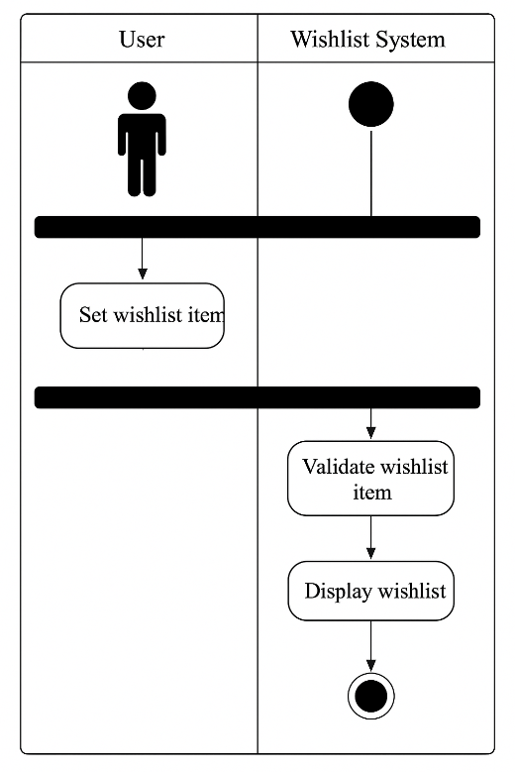
Figure 4.38: Wishlist Activity Diagram

The system's independent wishlist management feature is explained through Figure 4.38, which details the functionality that allows users to generate and maintain their personal desired acquisitions. When users access the wishlist section, they can add new wishlist items after providing information about the item name as well as its price, and including notes while offering an optional link to purchase. The system validates user data entry in real-time to check that all information has been completed correctly and that price values are positive and the wishlist item count does not exceed five items. Systematic validation succeeds before the item gets added through a progress bar interface, which shows funding achievement levels. Incremental funding by users triggers automatic system updates, which display progress bar changes and enable the display of ready-for-purchase items when enough funds are collected. The independent wishlist-tracking feature executes separately from account and budget or transaction processes described in Figure 4.38 since it functions as an exclusive goal-setting platform.

4.4.3 Sequence Diagram

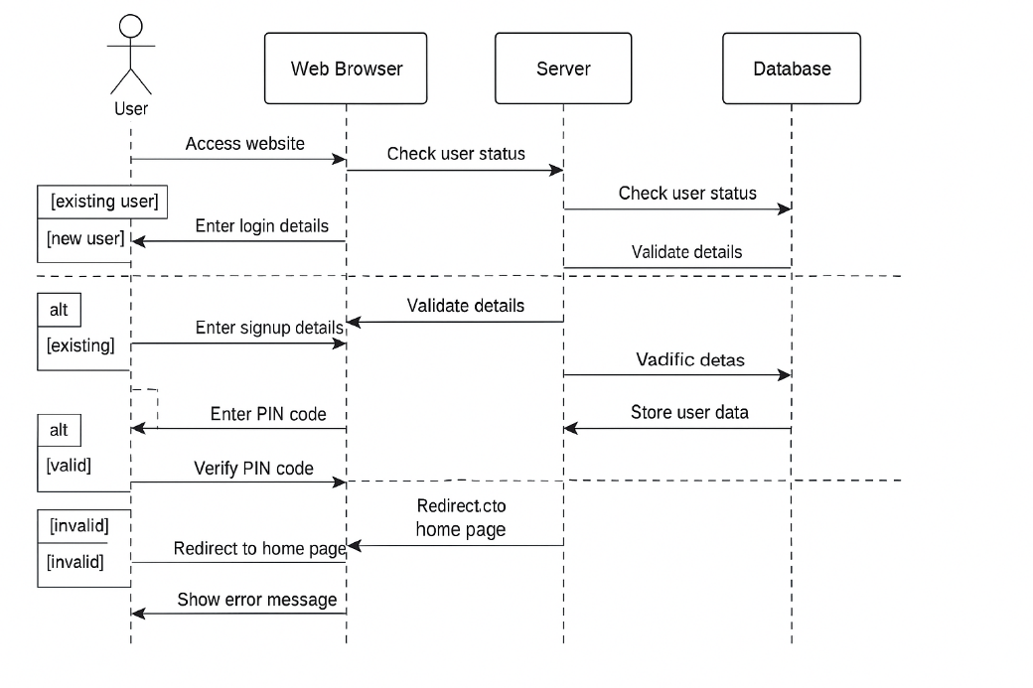
Figure 4.39: Login & Setup Sequence Diagram

System objects portray their intended dynamic communications through sequence diagrams (Sinambela et al., 2024). The core elements of our Personal Finance Management (PFM) system comprise front-end interface (UI widgets), back-end system (Python logic and validation scripts), and database (SQLite), as well as external actor roles for users. The login and signup activities track their dynamic communication pattern through the sequence diagram shown in Figure 4.39. The front-end interface detects user activity before sending a request to the back end to check user existence. The back-end database queries for the provided username, thus the system returns a confirmation regarding the user's status: whether they need to sign up or already possess an account. In the first component of the redirection logic (alt block), this response indicates whether users need to proceed to the registration form or must access the login page.
The front end collects information for new or existing users, where signup involves username, email, and password, while login requires only username and password. The program runs client-side validation for each field (username range, email Gmail format, and complex password) concurrently while conducting server-side verification to confirm unique values and validate existing information. The second alt block identifies correct from incorrect input, yet to be processed. New user data goes into the USERS table if valid, or user information is retrieved for login purposes, then a success message is returned to the front end. An error message is sent to the front-end user interface in case of invalid details.

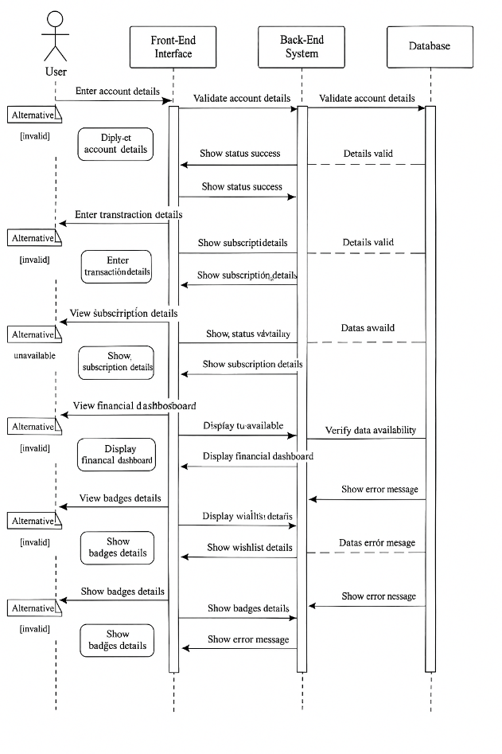
Figure 4.40: Features Sequence Diagram

The key features of our system, which use User and Front-End Interface and Back-End System and Database objects, are pictured in Figure 4.40. The system uses a standard workflow that starts when users input essential information such as record names and values, together with budget labels and transaction contents and subscription services, and wishlist items. The user interface collects these inputs and transfers them to the back-end system to perform validation procedures. A validation process is managed through an alternative condition that determines the validity status of input details. A successful double validation of inputs allows the system to store data in the database. A back-end system sends another confirmation to the front-end interface, which displays stored data through interactive visual indicators, including budget bars and transaction records, and a wishlist progress bar. The back end automatically sends error statuses to prompt front-end interfaces to show error messages to users when any user input proves invalid, such as missing fields, duplicate names, or non-numeric values.
The standalone dashboard function operates independently while it uses stored information in combination with the badge system. When users request to see the dashboard, the front end verifies the presence of linked data consisting of transactions, budgets, and account balances. The query reaches the back-end system, which examines existing database contents to verify chart data availability. The system will show the full dashboard interface that includes graphs and personalized recommendations if there is available data to process. The system displays an 'error message' indicating absent data, which will not produce an effective dashboard view. The back-end system automatically ponders the present conditions against badge standards, which rely on stored achievement metrics, including login streaks and budget use, and wishlist activities, until it shows valid awarded badges or errors for unmet requirements. The connected and validated workflow maintains system reliability through consistent functionality across our system core components.

CHAPTER 5: CONCLUSION
5.1 Summary of Paper & Research Objectives Achievement
Multiple studies regarding personal finance management (PFM) for Generation Z demonstrate that financial control is vital for long-term financial stability, but this crucial aspect gets ignored by substantial numbers within the population segment. This study analyzes how Generation Z manages their finances through different research studies, which demonstrate their financial challenges with limited knowledge about money, excessive dependence on digital transactions, as well as social media influencing their shopping habits. Generic financial applications fail Gen Z users because they lack customized options, their interfaces seem uninteresting, and their technical interface design confuses budget management, according to user testing results. Due to this situation, numerous people utilize conventional systems or dismiss budgeting in favor of poor savings habits, along with financial pressure. Our proposed personal finance management system functions as a customized budgeting system that addresses Gen Z requirements through an implementation using the SDLC framework and Agile methodology despite facing development limitations. The system includes motivational features like login streaks and badges, and intuitive elements including wishlists and personalized dashboards, together with necessary account management features, subscription tracking capabilities and transaction logging, and budget creation tools. Every component in our proposal was developed with attention to combining ease-of-use with practicality through combined real-time feedback and educational features. A new generation of users affirmed through testing that our system closed the existing personal finance tool deficiencies to create an accessible system that promotes consistent use for responsible money behavior.

All research targets of the project were accomplished through the creation of personalized financial management software made for Generation Z audiences. The research started by thoroughly examining budgeting apps along with finance tools that Gen Z users evaluated for their major shortcomings, which included subpar customization and confusing screen layouts, and minimal participation from users. The system includes features that support subscribers with expense tracking, along with alert functions for spending control, since its design prioritized Gen Z preferences. Financial education appeared naturally throughout the system through constantly changing financial statements alongside clear presentation screens, which promoted financial education by integrating it into everyday use. Through its design, the system aimed to establish sustainable budgeting behavior by utilizing Python and Google Colab for creating a user-friendly and interactive interface. Users maintained their engagement by receiving badges combined with streak counters, which served as motivating awards for maintaining active participation. A Wishlist function in the system enabled users to develop their savings for different duration goals, including travel experiences and education, as well as purchasing gadgets. Users from Gen Z find budgeting easier because the system unites crucial financial instruments and motivational interface design patterns to create personalized and effective budgeting solutions.

5.2 Limitation
A variety of restrictions emerged during the execution of our personal financial management system development work despite our initial implementation success. The absence of connection between real-time banking APIs and e-wallet platforms forces users to provide financial data by hand, leading to both inconvenience and diminished sustainable participation. The development environment based on Google Colab helped testing, while it blocks broader scalability options for user deployment. The financial literacy content relied on basic motivational tips and quotes, but better adaptive educational features were not feasible because of limited resources and time. Testing involved users who were members of Gen Z, but due to this limited sample size, their demographics did not properly reflect the wide-ranging financial practices and requirements observed throughout the whole population. The system presents constraints that should guide researchers and developers to enhance its functionality in upcoming versions of the system.

5.3 Recommendations
We outline essential future development recommendations that will boost the effectiveness together with usability, and impact of the proposed personal financial management system. Users would experience enhanced usability when the system implements real-time banking API integration with automatic e-wallet synchronization, which enables automated transaction import for complete balance monitoring. Our system would become more functional and usable for smartphone-oriented Gen Z users through the migration of its existing Google Colab setup to either mobile-native or web-based application frameworks. Financial literacy modules need advancement because they should offer individualized financial guidance and brief educational contents that adapt to user actions and financial targets, or payment behaviors to maintain learning progression. The upcoming versions of the user testing process must include tests with bigger participant samples from diverse Gen Z populations to achieve a complete understanding of user requirements and preferences. The application's functionality can be improved through the addition of AI budget tips and community functions that enable user-sharing of savings goals. Such changes would strengthen the system's capabilities while making it more comprehensive and shrewd financial software that matches Generation Z behavioral patterns.

5.4 Future Research
Additional studies need to be conducted afterward for the personal financial management system because they will show various ways to boost its effectiveness. Research shows that artificial intelligence creates intelligent models that track spending behavior to provide decisions on better financial choices. Research should move ahead to explore how gamification elements impact Gen Z retention levels during their formation of new economic behaviors. Future research on embedded system financial modules requires an investigation of user education development patterns over time. Budgeting systems achieve better recommendations through the integration of emotional and psychological factor analysis tools to monitor behavioral patterns caused by cognitive bias as well as mood fluctuations. The budgeting systems would improve their behavior-aware financial advice through this method. This research needs to assess user-designed finance system operations by conducting parallel investigations on people from different age groups and cultural backgrounds to detect approach variations. Additional exploration of user behavior during research will provide deep information that guides the development of adjustable financial tools and inclusive features that succeed in reaching users.

REFERENCES
Adewumi, T., Olutimehin, D. O., Ewim, C. P.-M., & Ibeh, A. I. (2023). Developing an Inclusive Framework for Digital Payment Systems: Solving Barriers to Financial Inclusion in Underserved Regions. International Journal of Social Science Exceptional Research, 2(1), 143-155.
Agarwal, V., Ray, R., & Varghese, N. (2024). An AI-Powered Personal Finance Assistant: Enhancing Financial Literacy and Management. FOSS Approaches towards Computational Intelligence and Language Technology (FOSS-CIL T24).
Annuity.org. (2025, March 31). Personal Finance: A Practical guide to managing your money. https://www.annuity.org/personal-finance/
Atkinson, A., & Messy, F. (2012). Measuring financial literacy. OECD Working Papers on Finance, Insurance Private Pensions. https://doi.org/10.1787/5k9csfs90fr4-en
Bank of America. (2020). Financial Life Benefits Report. https://about.bankofamerica.com/en/our-commitments/financial-life-benefits
BBC News. (2019). Capital One Data Breach Affects 100 Million in US. https://www.bbc.com/news/world-us-canada-49159859
Behavioral Economics Lab, Harvard University. (2019). Insights on Financial Behavior and Decision-Making. https://projects.iq.harvard.edu/behavioral-economics
Bera, S., & Bandyopadhyay, S. (2022). Goal setting and saving in the FinTech era. The Journal of Finance, 79(3), 1931–1976. https://doi.org/10.1111/jofi.13339
Bera, S., & Bandyopadhyay, S. (2022). Goal Setting and Saving in the FinTech Era. Journal of Finance, 79(3), 1931-1976.
Chen, L., Li, Y., Wu, X., & Luo, J. (2017). Blockchain-Based Cross-Platform Financial Data Sharing. IEEE Big Data Conference. https://doi.org/10.1109/BigData.2017.8258454
Choi, J., Lee, S., & Kim, D. (2022). Financial Management among Youth. Journal of Youth Studies, 25(4), 567-583.
Consumer Financial Protection Bureau (CFPB). (2017). Behavioral Insights into Financial Decision Making. https://www.consumerfinance.gov/data-research/research-reports/
Deep, N., & Chawla, N. V. (2023). Predictive Budgeting and Planning with AI in Oracle EPM: Automating Financial Projections. International Journal of Forecasting, 39(2), 456-472.
Deloitte. (2020). AI in Financial Services: Unlocking the Potential of Artificial Intelligence. https://www2.deloitte.com/us/en/pages/financial-services/articles/artificial-intelligence-in-financial-services.html
Ernst & Young (EY). (2019). Global FinTech Adoption Index. https://www.ey.com/en_gl/financial-services/global-fintech-adoption-index
Experian. (2021). Consumer Financial App Usage Trends. https://www.experian.com/blogs/news/2021/05/new-report-consumer-financial-app-usage
Faulkner, A. E. (2015). Financial literacy education in the United States: Exploring popular personal finance literature. Journal of Librarianship and Information Science, 49(3), 287–298. https://doi.org/10.1177/0961000615616106
Fernandes, D., Lynch, J. G., & Netemeyer, R. G. (2014). Financial literacy, financial education, and downstream financial behaviors. Management Science, 60(8), 1861–1883. https://doi.org/10.1287/mnsc.2013.1849
Financial Health Network. (2021). U.S. Financial Health Pulse Trends Report. https://finhealthnetwork.org/research/financial-health-pulse/
Financial Industry Regulatory Authority (FINRA). (2020). National Financial Capability Study. https://www.finra.org/investors/insights/financial-capability-study
Fogg, B. J., Cuellar, G., & Danielson, D. (2022). Behavior Triggers in Finance Apps: A Psychological and Technological Framework. Journal of Behavioral Finance, 23(1), 15-29.
Garg, S., & Sharma, V. (2020). A Survey on Personal Finance Apps: Techniques and Trends. International Journal of Advanced Science and Technology, 29(4), 541–551. http://sersc.org/journals/index.php/IJAST/article/view/5848
Gomber, P., Kauffman, R. J., Parker, C., & Weber, B. W. (2018). On the Fintech Revolution: Interpreting the Forces of Innovation, Disruption, and Transformation in Financial Services. Journal of Management Information Systems, 35(1), 220–265. https://doi.org/10.1080/07421222.2018.1440766
Gudmunson, C. G., & Danes, S. M. (2011). Family Financial Socialization: Theory and Critical review. Journal of Family and Economic Issues, 32(4), 644–667. https://doi.org/10.1007/s10834-011-9275-y
Hean, O., Saha, U., & Saha, B. (2024). Can AI Help with Your Personal Finances? arXiv preprint arXiv:2412.19784. ​
Hilgert, M. A., Hogarth, J. M., & Beverly, S. G. (2003). Household Financial Management: The Connection between Knowledge and Behavior. Federal Reserve Bulletin. https://www.federalreserve.gov/pubs/bulletin/2003/0703lead.pdf
Huang, Y., & Chen, X. (2023). The Cross-Cultural Perspective on Operational Management and Strategic Decision-Making in the Context of Globalization. Journal of International Business Studies, 54(3), 456-478.
Imawan, R., Putra, W. P., Alqahtani, R., Milakis, E. D., & Dumchykov, M. (2025). Enhancing Financial Literacy in Young Adults: An Android-Based personal Finance management tool. Journal of Hypermedia & Technology-Enhanced Learning (J-HyTEL), 3(1), 64–88. https://doi.org/10.58536/j-hytel.166
ISSN 2746-5667 (Online) | Proceeding International Conference on Business and Social Science | The ISSN Portal. (n.d.). https://portal.issn.org/resource/ISSN/2746-5667
JPMorgan Chase & Co. (2020). Youth Financial Health Report. https://www.jpmorganchase.com/impact/our-approach/youth-programs
Khamayseh, B., Arman, N., & K, F. (2022). Security Requirements Classification into Functional and Non-functional. Ppu.edu. http://localhost:8080/xmlui/handle/123456789/8872
Kwon, Y., Park, J., & Lee, S. (2022). Digital Wallet
Lau, J., Shan, L., & Li, H. (2023). Leading Generation Z's Financial Literacy Through Financial Education: Contemporary Bibliometric and Content Analysis in China. SAGE Open, 13(3). ​
Lusardi, A., & Mitchell, O. (2011). Financial Literacy and Planning: Implications for Retirement wellbeing. https://doi.org/10.3386/w17078
Lusardi, A., & Mitchell, O. S. (2014). The Economic Importance of Financial Literacy: Theory and Evidence. Journal of Economic Literature, 52(1), 5–44. https://doi.org/10.1257/jel.52.1.5
Mandell, L., & Klein, L. S. (2009). The Impact of Financial Literacy Education on Subsequent Financial Behavior. Journal of Financial Counseling and Planning, 20(1). https://papers.ssrn.com/sol3/papers.cfm?abstract_id=2224231
McKinsey & Company. (2020). Data Ecosystems in Financial Services. https://www.mckinsey.com/industries/financial-services/our-insights/data-ecosystems-in-financial-services
Mok, K. (2022). First impressions of a financial AI assistant: Differences between high and low trust users. Frontiers in Psychology, 13, 1057960.
MVC Architecture - Detailed Explanation. (2022, May 27). InterviewBit. https://www.interviewbit.com/blog/mvc-architecture/
National Endowment for Financial Education | NEFE. (n.d.). https://www.nefe.org/
Pargaonkar, S. (2023). A Comprehensive Research Analysis of Software Development Life Cycle (SDLC) Agile & Waterfall Model Advantages, Disadvantages, and Application Suitability in Software Quality Engineering. International Journal of Scientific and Research Publications, 13(8), 120–124. https://doi.org/10.29322/ijsrp.13.08.2023.p14015
Personal finance management system - UTAR Institutional Repository. (n.d.-b). http://eprints.utar.edu.my/6631/
Pew Research Center. (2020). Economic Fallout from COVID-19 Continues to Hit Lower-Income Americans the Hardest. https://www.pewresearch.org/social-trends/2020/09/24/economic-fallout-from-covid-19-continues-to-hit-lower-income-americans-the-hardest/
PISA 2018 Results (Volume IV). (2020). In Programme for international student assessment/Internationale Schulleistungsstudie. https://doi.org/10.1787/48ebd1ba-en
Sarker, P., Rahman, M., & Islam, N. (2021). Gamification of Mobile Money Payment for Generating Customer Engagement: A Study on the Social Impact and Customer Value Theories. Technological Forecasting and Social Change, 172, 120999.
Shankar, S. P., & Chaudhari, S. S. (2023). Framework for the Automation of SDLC Phases using Artificial Intelligence and Machine Learning Techniques. International Journal on Recent and Innovation Trends in Computing and Communication, 11(6s), 379–390. https://doi.org/10.17762/ijritcc.v11i6s.6944
Singh, R., Sharma, S., & Gupta, A. (2023). AI-Driven Financial Forecasting: Innovations and Implications for Accounting Practices. International Journal of Financial Studies, 11(9), 226. ​
Sk, P. et al., 2020. Basics of Research Methods: An Overview for Beginners. The Indian practitioner, Volume 73, pp. 37-40.
Stanford University. (2023). Stanford launches Initiative for Financial Decision-Making to transform personal finance education. Stanford Institute for Economic Policy Research. ​
Stefanov, T., Stefanova, M., Varbanova, S., & Temelkov, S. (2024). Personal Finance Management Application. TEM Journal, 13(3), 2066-2075.
Talasila, S. D. (2024). AI-Driven Personal Finance Management: Revolutionizing Budgeting and Financial Planning. International Research Journal of Engineering and Technology (IRJET), 11(07), 397-403.
The Improvement of Financial Literacy and digital payment Behavior in Generation Z: A literature review. (2024). International Journal of Business and Technology Management. https://doi.org/10.55057/ijbtm.2024.6.2.55
Varghese, N., Ray, R., & Agarwal, V. (2023). Chatbots for Customer Service in Financial Entities—A Comprehensive Systematic Review. Journal of Financial Services Research, 59(2), 345-367.
Wu, Y., & Li, J. (2021). Adoption of Fintech Services in Young Students: Empirical Approach in the Colombian Context. Economies, 11(9), 226. ​
Xiao, J. J., & Porto, N. (2017). Financial Education and Financial Satisfaction: Financial Literacy, Behavior, and Capability as Mediators. International Journal of Bank Marketing, 35(5), 805–817. https://doi.org/10.1108/IJBM-01-2016-0009

APPENDICES

